**UMBC**

**IS420 Database Application Development**

Spring 2018

Group Project

**Hotel Management System**

**Team Everest**

**Developed By:**

Kabin Dulal

Diwakar Sharma

Sijan Karki

05/10/2017

**Individual Tasks**

**Sijan Karki: Member 1 Plus 18 and 23**

**Numbers (1, 2, 3, 4, 5, 6, 18, 23)**

**Kabin Dulal: Member 2 Plus 16, 19 and 22**

**Numbers (7, 8, 9, 10, 16, 19, 22)**

**Diwakar Sharma: Member 3 Plus 17, 20 and 21**

**Numbers (11, 12, 12, 14, 15, 17, 20, 21)**

* Member 1: Sijan Karki
  1. Add a new hotel: Create a new hotel with appropriate information about the hotel as input parameters

--Procedure Created By SIJAN KARKI

-- This procedure is used to add a new hotel in the database

--The inputs will be all of the information about hotels

--The output wil be the a confirmation message

--creating a process

**create** **or** **replace** **procedure** hotel_entry

**(** --declaring variables

Haddr **in** HOTELS**.**HOTEL_ADDR**%type,**

Hcity **in** HOTELS**.**HOTEL_CITY**%type,**

Hstate **in** HOTELS**.**HOTEL_STATE**%type,**

HZipcode **in** HOTELS**.**HOTEL_ZIP_CODE**%type,**

HPhone **in** HOTELS**.**Hotel_phone**%type,**

Hstatus **in** HOTELS**.**HOTEL_STATUS**%type** **)**

**is**

**begin**

**insert** **into** hotels **values** **(**HOTEL_CODE_SEQ**.NEXTVAL,** Haddr**,** Hcity**,** Hstate**,** HZipcode**,**HPhone**,** Hstatus**);** --inserting values

dbms_output**.**put_line**(**'Hotel inserted successfully, Your new Hotel code is' **||**' '**||** HOTEL_CODE_SEQ**.currval);**

**exception**

**when** dup_val_on_index **then**

dbms_output**.**put_line**(**'Hotel Already exists'**);**

**END;**

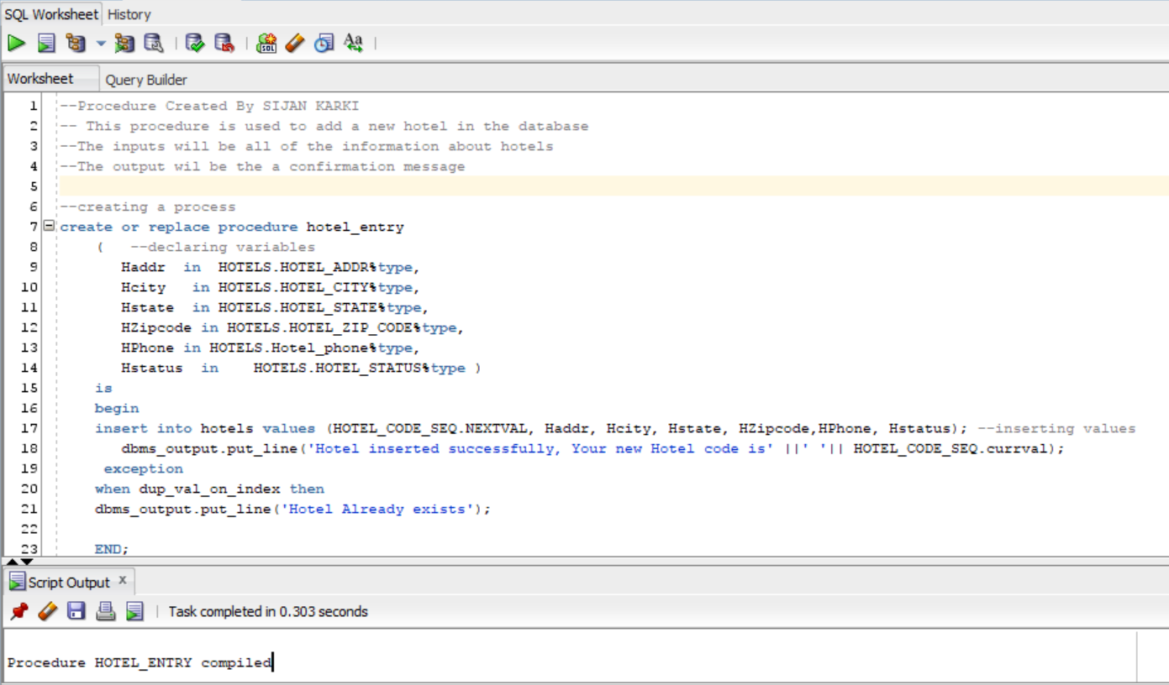

* 1. Find a hotel: Provide as input the address of the hotel and return its hotel ID

--Procedure Created By SIJAN KARKI

-- This procedure is used to Find Hotel

--The input will be hotel Address

--The output wil be the Hotel ID

--creating a process

**create** **or** **replace** **procedure** Find_hotel**(**ad **in** **varchar2)**

**as**

h_code HOTELS**.**HOTEL_CODE**%type;**

**begin**

**select** hotel_code **into** h_code **from** hotels **where** HOTEL_ADDR **=** ad**;**

DBMS_OUTPUT**.**put_line**(**'The ID of the selected hotel is '**||**h_code**);**

**exception**

**when** no_data_found **then**

DBMS_OUTPUT**.**put_line**(**'No Hotel exist'**);**

**end;**

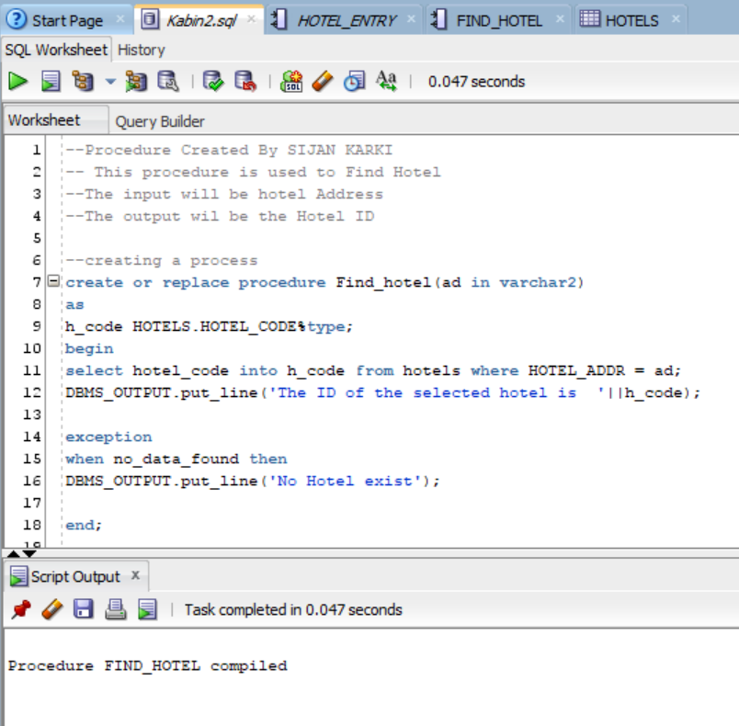

--calling prcedure

**set** serveroutput **on**

**execute** find_hotel**(**'24 bukhi palace'**);**

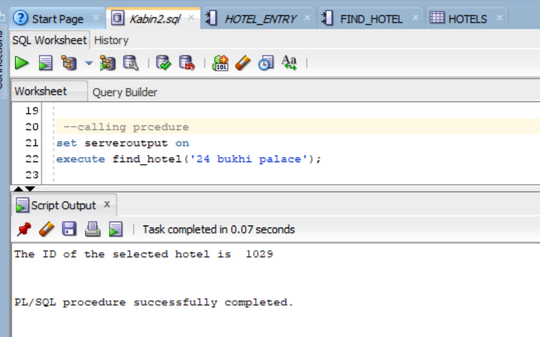

--calling prcedure

**set** serveroutput **on**

**execute** find_hotel**(**'24 KKKKk'**);**

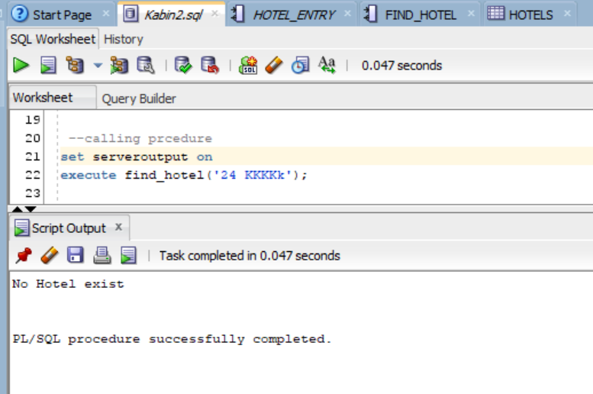

* 1. Sell existing hotel: Sell a hotel by providing its hotel ID. Mark it as sold, do not delete the record.

--Procedure Created By SIJAN KARKI

-- This procedure is used to sell hotel

--The input will be hotel Code

--The output wil be the confirmation message, Hotel status will be changed from Open to Sold,

--All of the rooms in the hotel will be made inactive

--creating a process

**create** **or** **replace** **procedure** Sold_hotel **(** Hcode **in** **varchar2)** **as**

hotel_stat hotels**.**hotel_status**%type;**

sold_ex **EXCEPTION;** --declaring an exception

**begin**

**select** hotel_status **into** hotel_stat **from** hotels **where** hotel_code**=**hcode**;**

**if** hotel_stat **=** 'Sold' **then**

**raise** sold_ex**;** --if hotel_stat is sold then it will call this exception.

**else**

**update** hotels **set** hotel_status **=** 'Sold' **where** HOTEL_CODE **=** Hcode**;** --update statements

**update** rooms **set** room_status **=** 'Inactive' **where** hotel_code**=** hcode**;**

dbms_output**.**put_line **(**'Hotel '**||**hcode**||**' successfully sold'**);**

**end** **if;**

**exception** --handeling exception

**when** sold_ex **then**

dbms_output**.**put_line **(**'Hotel '**||**hcode**||**' already sold'**);**

**end;**

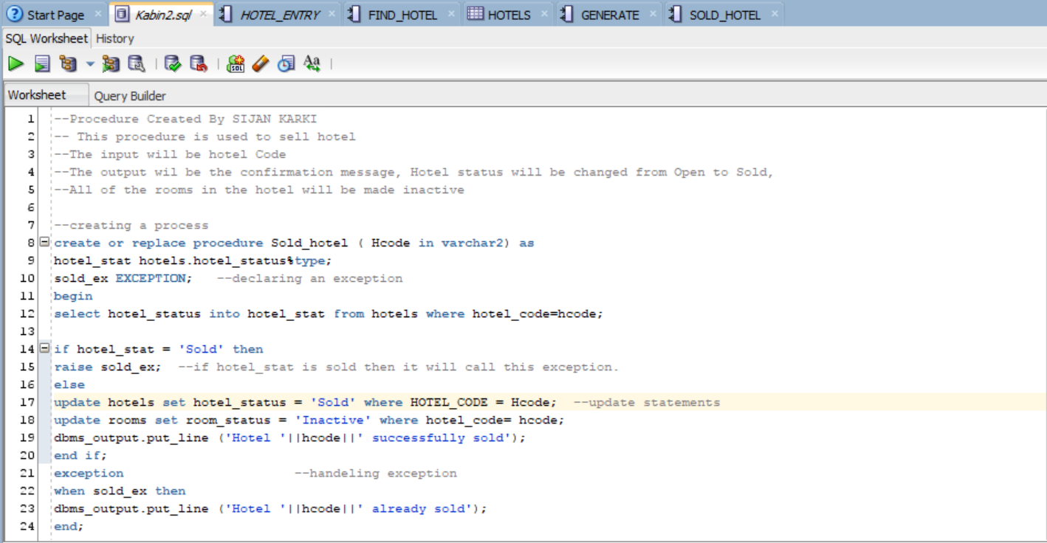

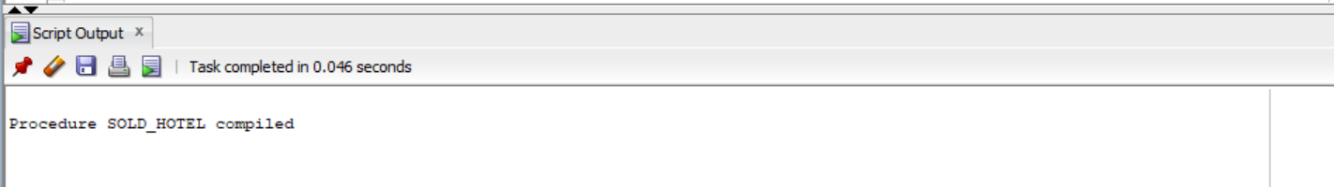

--calling a procedure

**set** serveroutput **on;**

**execute** sold_hotel**(**'1002'**);**

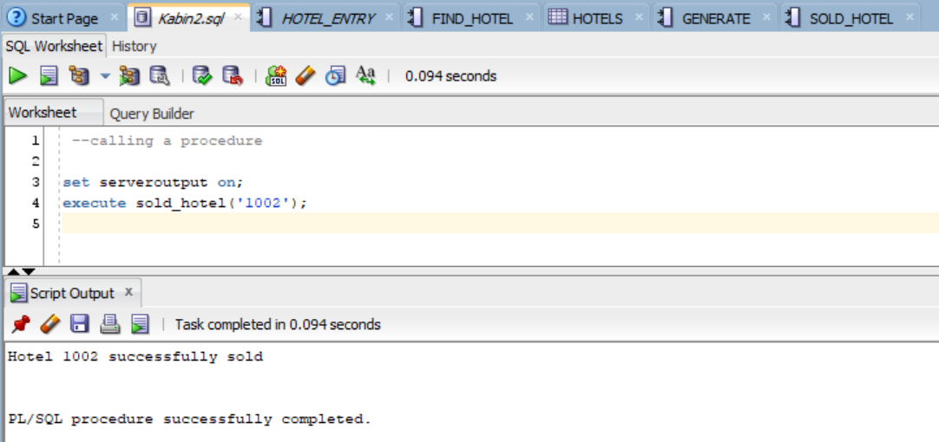

--calling a procedure

**set** serveroutput **on;**

**execute** sold_hotel**(**'1002'**);**

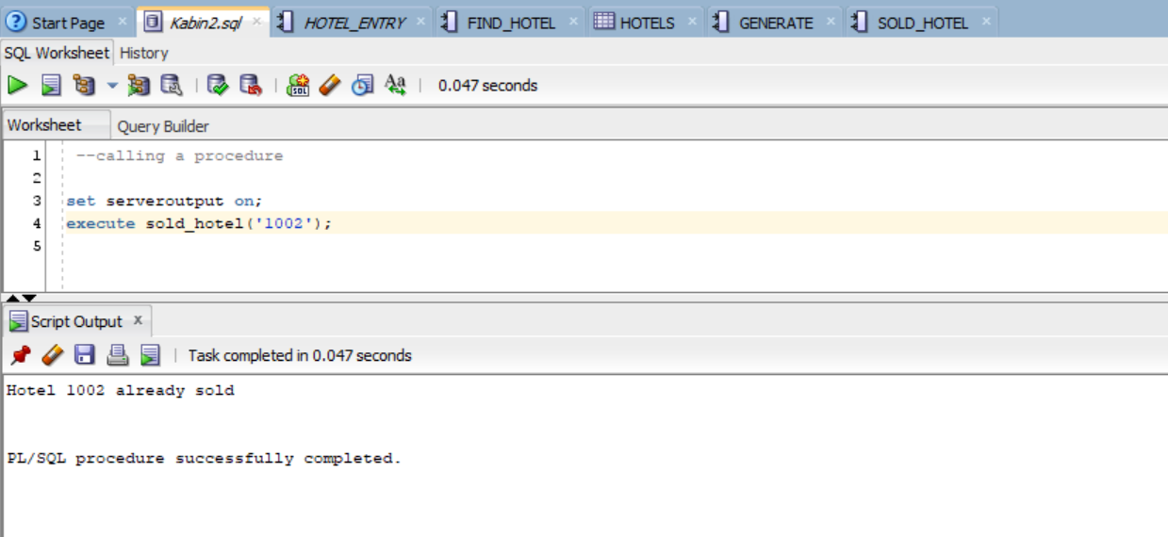

* 1. Display hotel info: Given a hotel ID, display all information about that hotel

--Procedure Created By SIJAN KARKI

-- This procedure is used to display hotel Information

--The input will be hotel Code

--The output will be all of the information about the specified hotel

--creating a process

create or replace procedure display_hotel_info_by_ID

(ho_id in number)--creating a process

is

cursor c1 is --creating a cursor

select hotel_code, hotel_addr, hotel_city, hotel_state, hotel_zip_code,

hotel_phone, hotel_status

from hotels

where hotel_code = ho_id;

x c1%rowtype;

ishotel number;

begin

select hotel_code into ishotel from hotels where hotel_code=ho_id;

open c1;

loop

fetch c1 into x; --c1 is fetched into x

exit when c1%NOTFOUND;

dbms_output.put_line('Hotel Code: '||x.hotel_code);

dbms_output.put_line('Address: '||x.hotel_addr||', '||x.hotel_state||', '||x.hotel_zip_code);

dbms_output.put_line('Phone: '||x.hotel_phone);

dbms_output.put_line('Status: '||x.hotel_status); --print statements

end loop;

EXCEPTION

when no_data_found then

dbms_output.put_line('Hotel Id is invalid, Please enter the correct valid hotel ID');

end;

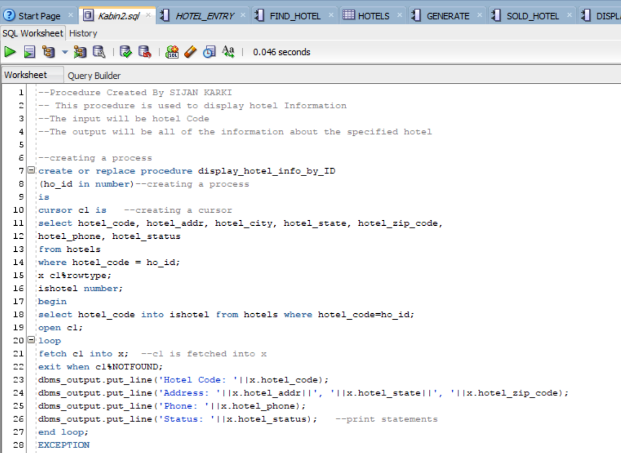

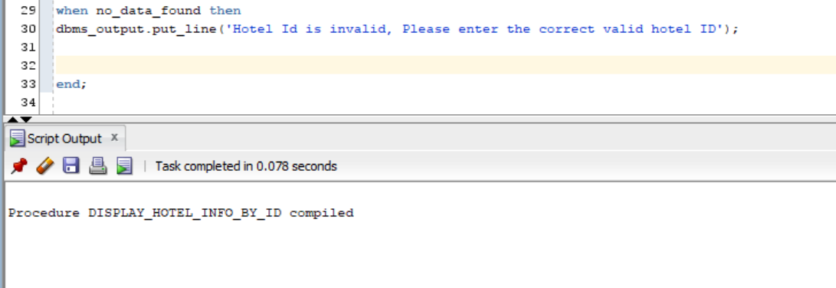

set serveroutput on;

execute display_hotel_info_by_ID(1008);

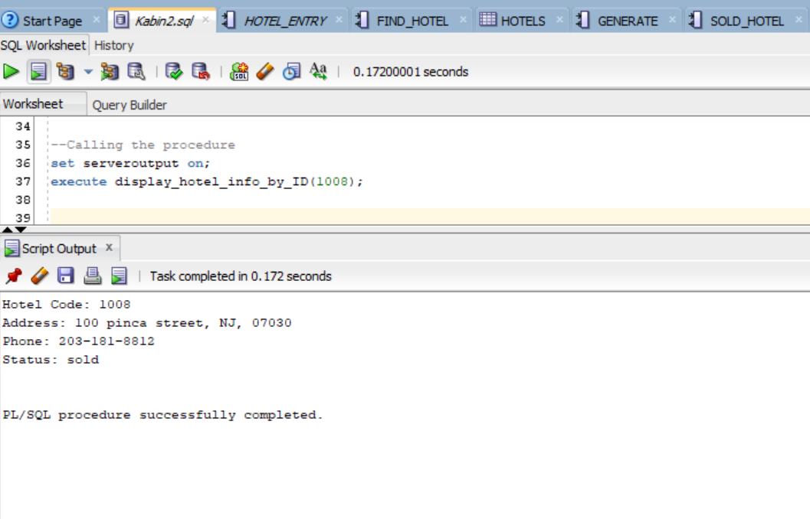

set serveroutput on;

execute display_hotel_info_by_ID(108);

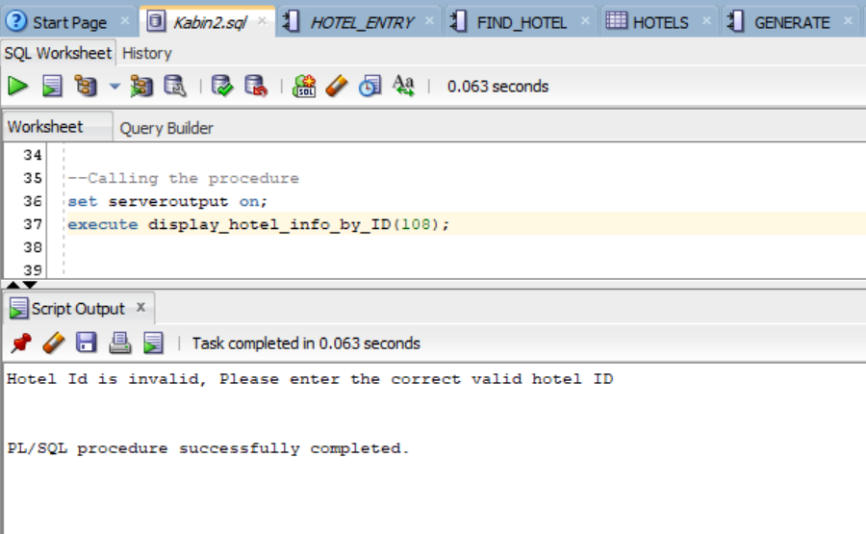

* 1. Sold Hotels: Print all sold hotel information. Show hotel ID, location, etc.

--Procedure Created By SIJAN KARKI

-- This procedure is used to display the sold hotel Information

--No inputs

--The output will be all of the information about the sold hotel

--creating a process

create or replace procedure show_sold_hotels --creating a process

is

cursor c1 is --creating a cursor

select hotel_code, hotel_addr, hotel_city, hotel_state, hotel_zip_code,

hotel_phone, hotel_status

from hotels

where hotel_status = 'sold';

x c1%rowtype;

begin

open c1;

dbms_output.put_line('--------------------------------Sold Hotel Information-----------------------------------:') ;

dbms_output.put_line('-----------------------------------------------------------------------------------------:') ;

loop

fetch c1 into x; --c1 is fetched into x

exit when c1%NOTFOUND;

dbms_output.put_line('Hotel Code: '||x.hotel_code);

dbms_output.put_line('Address: '||x.hotel_addr||', '||x.hotel_state||', '||x.hotel_zip_code);

dbms_output.put_line('Phone: '||x.hotel_code);

dbms_output.put_line('Status: '||x.hotel_status);

dbms_output.put_line('-----------------------------------------------------'); --print statements

end loop;

exception

when no_data_found then

dbms_output.put_line('No hotels are sold') ;

close c1;

end;

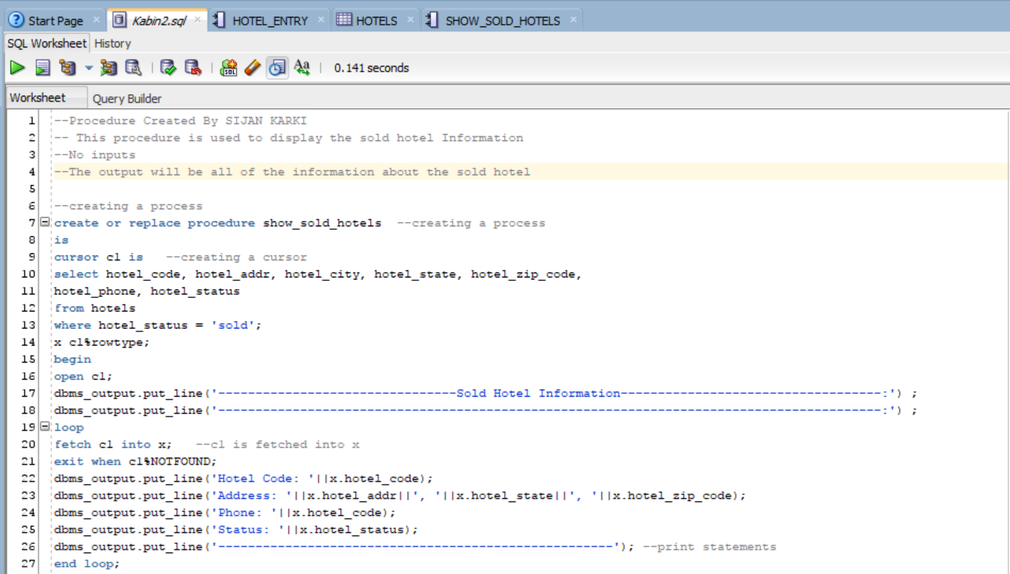

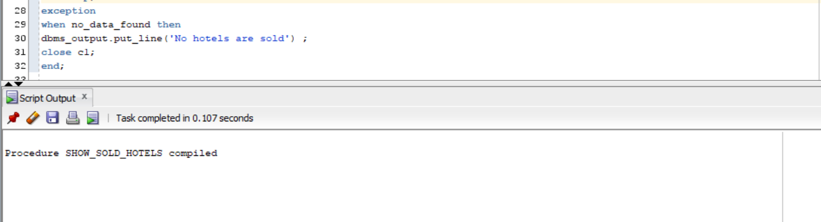

--executing the procedure

set SERVEROUTPUT ON;

execute show_sold_hotels;

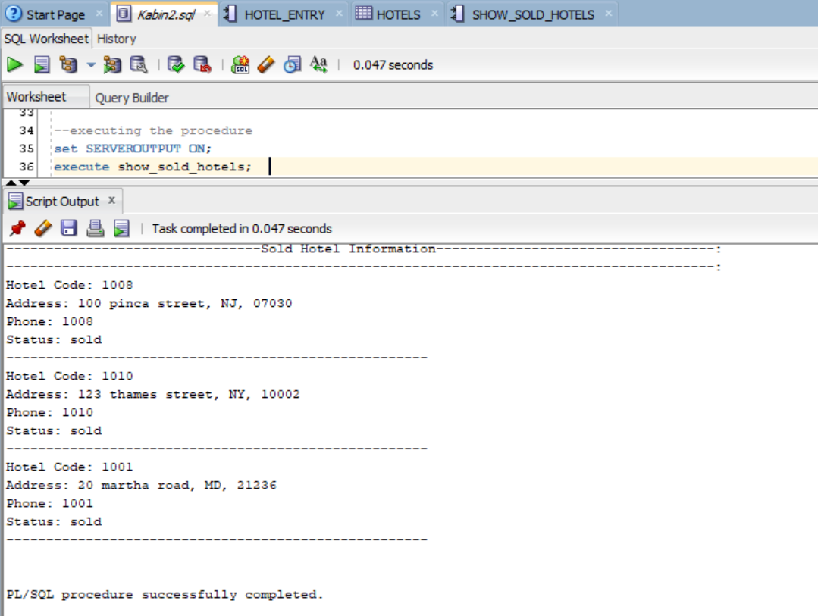

* 1. Report Hotels In State: Given a state, display information of all hotels in that particular state.

--Procedure Created By SIJAN KARKI

-- This procedure is used to display all the hotels in the state

-- State will be inputted as an input

--The output will be all of the information about the hotels in the given state

--creating a process

create or replace procedure display_hotel_info_by_state

(ho_state in varchar2) --creating a process

is

cursor c1 is --creating a cursor

select hotel_code, hotel_addr, hotel_city, hotel_state, hotel_zip_code,

hotel_phone, hotel_status

from hotels

where hotel_state = ho_state;

x c1%rowtype;

begin

open c1;

loop

fetch c1 into x; --c1 is fetched into x

exit when c1%NOTFOUND;

dbms_output.put_line('Hotel State: '||ho_state) ;

dbms_output.put_line('Hotel Code: '||x.hotel_code);

dbms_output.put_line('Address: '||x.hotel_addr||', '||x.hotel_zip_code);

dbms_output.put_line('Phone: '||x.hotel_phone);

dbms_output.put_line('Status: '||x.hotel_status);

dbms_output.put_line('-----------------------------------------------------'); --print statements

end loop;

close c1;

end;

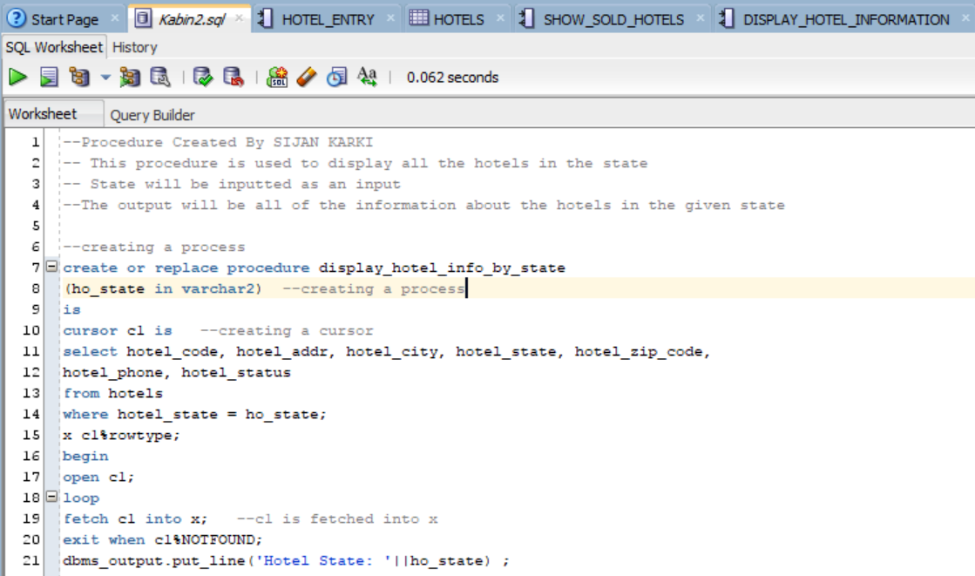

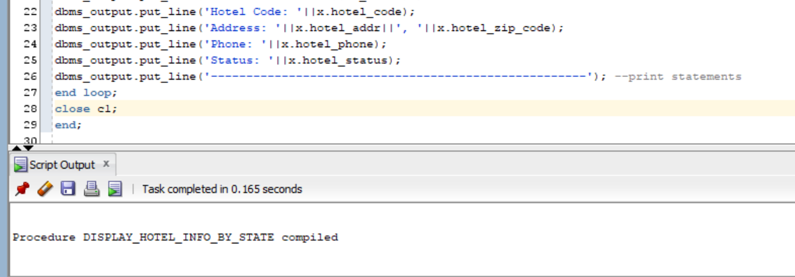

set serveroutput on;

execute display_hotel_info_by_state('NJ');

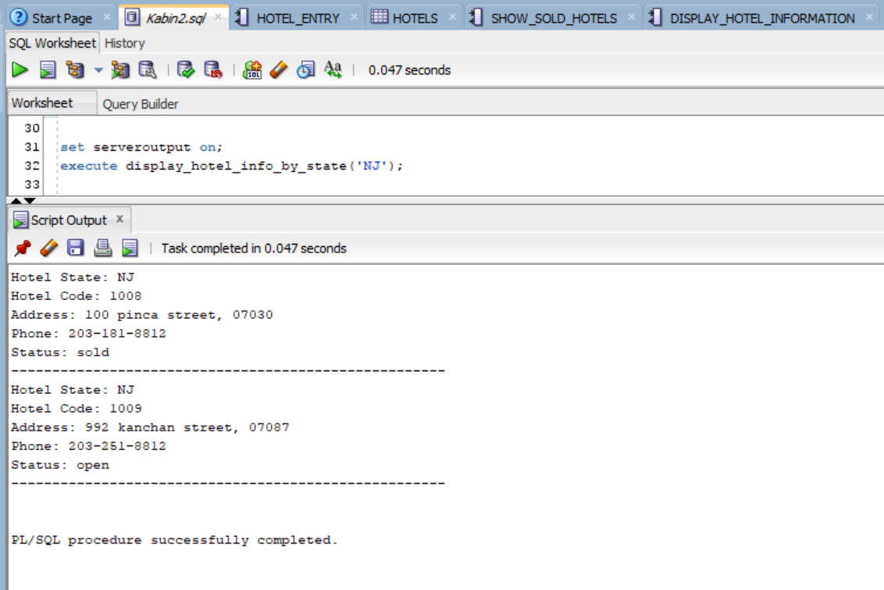

* Member 2: Kabin Dulal
  1. Make a reservation: Input parameters: Hotel ID, guest’s name, start date, end date, room type, date of reservation, etc. Output: reservation ID (this is called confirmation code in real-life). NOTE: Only one guest per reservation. However, the same guest can make multiple reservations.

This function is created by kabin Dulal

--This is used to check if the customer exist or not

create or replace function check_customer(cust_code in number) return number

is

custcode H_customers.customer_code%type;

begin

select customer_code into custCode from H_customers where Customer_code = cust_code;

return custcode;

exception

when no_data_found then

return -1;

end;

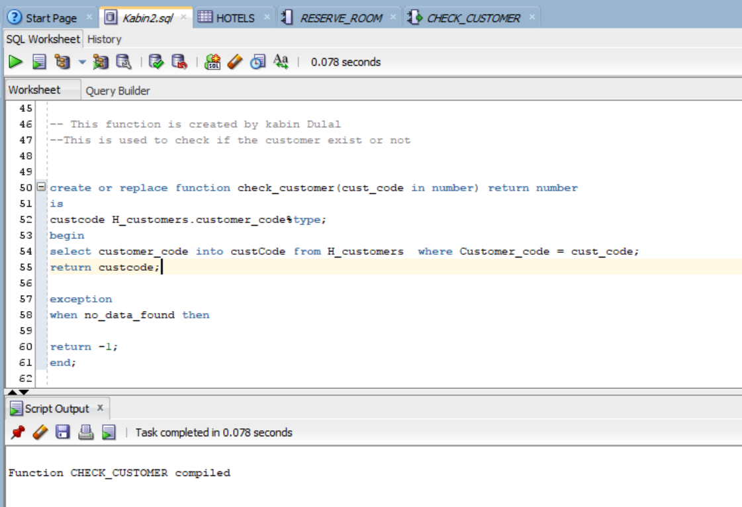

-- This function is created by kabin Dulal

--This is used to check if the hotel exist or not

create or replace function check_hotel(Hotel_c in number) return number

is

Hcode number;

begin

select hotel_code into Hcode from hotels where Hotel_code = hotel_c;

return hcode;

exception

when no_data_found then

return -1;

end;

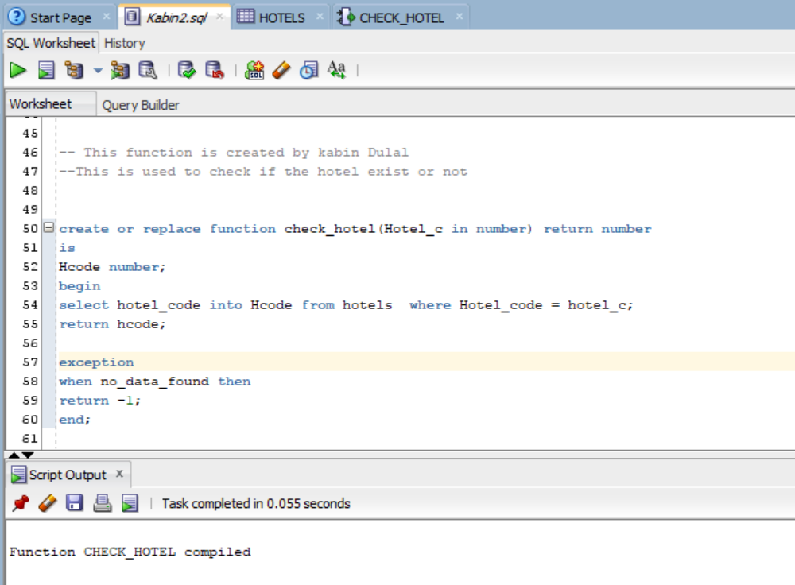

-- This function is created by kabin Dulal

--This is used to get the room number from the inputted values

create or replace function get_room (hotel_c in number,in_date in date, out_date in date, room_d in varchar2, Num_bed in number ) return number

is

room_num rooms.room_code%type;

begin

-- returns a available room on the specified hotel on the specified date

select r.room_code into room_num from rooms R, room_types RT where

RT.room_desc = room_d and

RT.NO_OF_BEDS = Num_bed and

R.Room_status = 'open' and

R.hotel_code = hotel_c and

RT.room_type_code = R.Room_type_code And

R.room_code not in (select room_code from RESERVATIONS where check_in_date = in_date and check_out_date = Out_date and reservation_stat = 'Booked') and

rownum <2;

return room_num;

exception

when no_data_found then

return -1;

end;

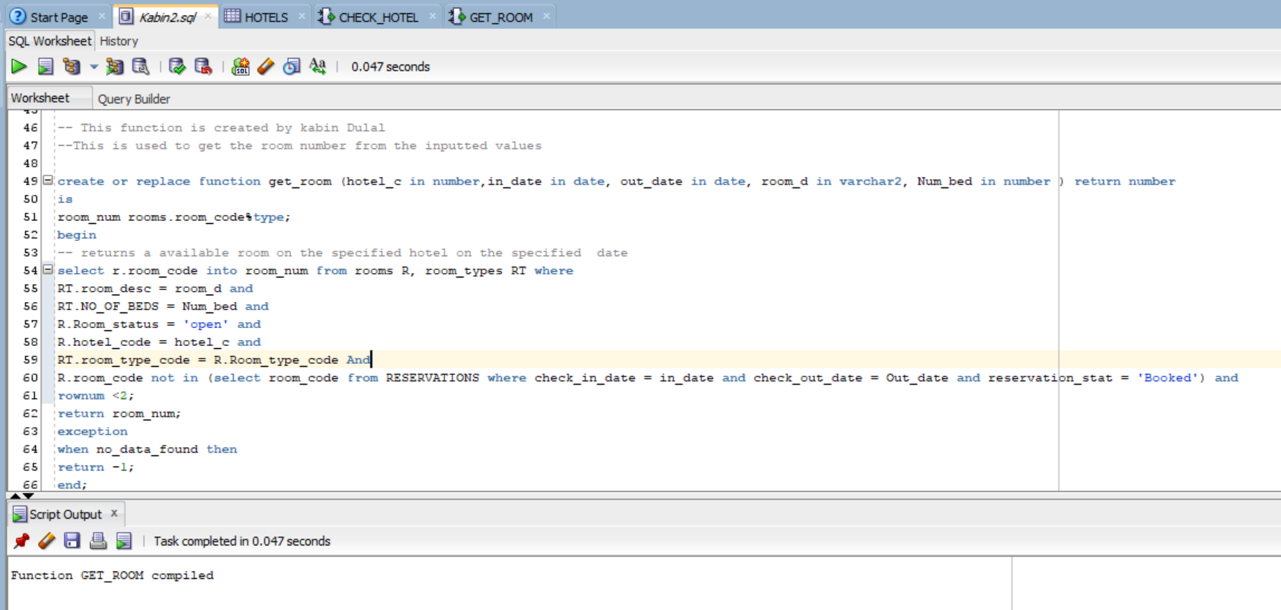

-----The Following procedure that calls all the above function and makes a reservation

--Procedure Created By Kabin Dulal

-- This procedure is used to make a reservation

/*Inputs are, customer id, Guest name, check in date, check out date,

Total Number of guest, room_type and number of beds*/

--This procedure calls three different functions to complete the task.

--The output will Reservation number or any error message

--creating a process

create or replace Procedure reserve_room

( cust_code in number, hotel_c in number, G_name in varchar2,in_date in date,

out_date in date, Total_guests in number, room_d in varchar2, Num_bed in number

)

as

roomno number;

Hcode number;

custcode number;

no_customer exception;

no_hotel exception;

no_room exception;

BEGIN

Hcode:= check_hotel(hotel_c);--calling Check_hotel function

Custcode:= Check_customer (cust_code);--calling check_customer function

roomno:= get_room(Hotel_c, in_date, out_date, room_d, Num_bed);-- Gets rom number and set to RoomNo

--check if anything went wrong and prints what went wrong

if hcode<1 then

dbms_output.put_line ('Hotel '||Hotel_c||' Does not Exist');

elsif Custcode<1 then

dbms_output.put_line ('The customer ID is invalid, Please Enter the corrrect Customer ID');

dbms_output.put_line ('If You are New Customer, Please Sign UP');

elsif roomno<1 then

dbms_output.put_line ('There are no room available of this type in this hotel, Please Change your Room types or look for a new hotel');

else

Insert into RESERVATIONS(RESERVATION_CODE,GUEST_NAME,CHECK_IN_DATE,CHECK_OUT_DATE,RESERVATION_DATE,

NO_OF_GUESTS,CUSTOMER_CODE,HOTEL_CODE,ROOM_CODE,RESERVATION_STAT)

values

(RESERVE_SEQ.NEXTVAL,G_name,TO_DATE(in_date,'DD-MON-RR'),To_date(Out_date,'DD-MON-RR'),

To_date(sysdate,'DD-MON-RR'),total_guests,custcode,hcode,Roomno,'Booked');

DBMS_output.put_line ('Congratulations, your reservation is booked,');

DBMS_OUTPUT.PUT_LINE('Your reservation code is: ' || RESERVE_SEQ.CURRVAL);

end if;

END;

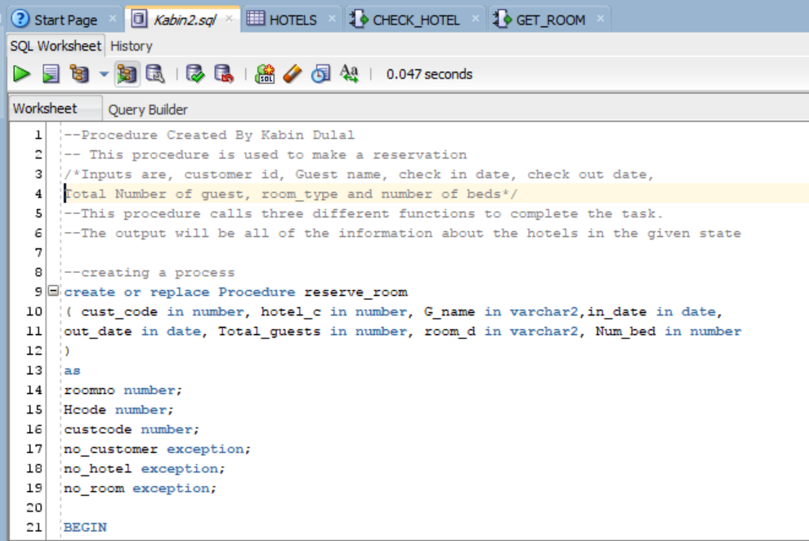

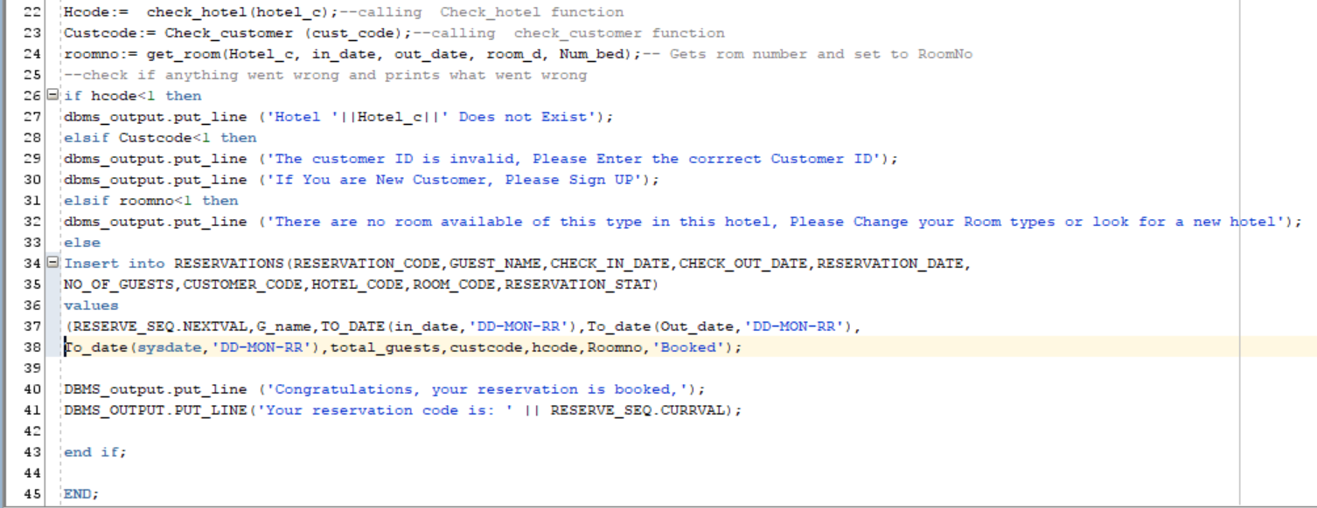

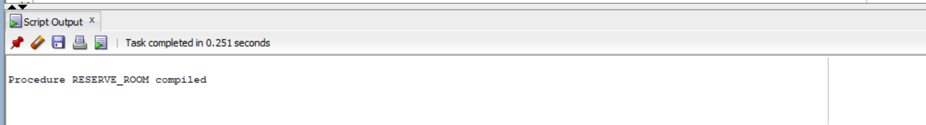

set serveroutput on

execute reserve_room(2018000, 1004,'Batman patel','23-APR-18','24-APR-18', 2,'suite',2);

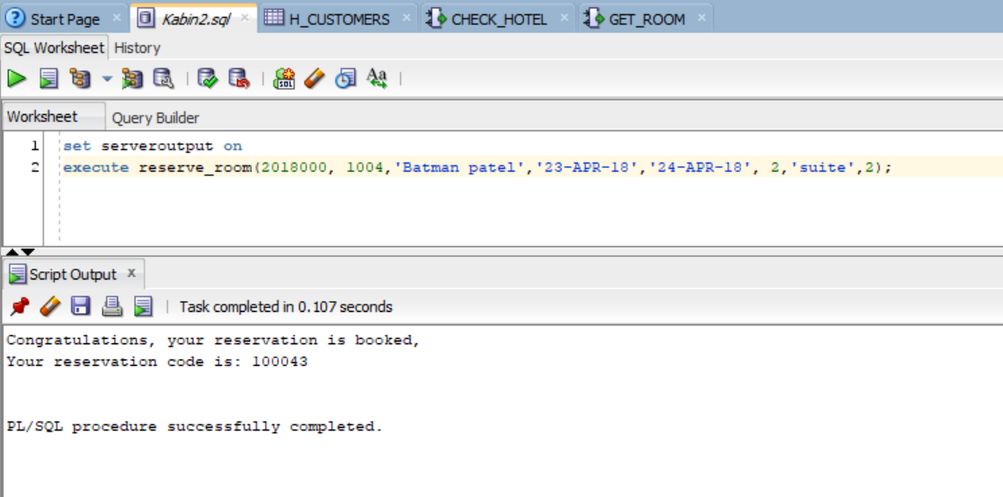

set serveroutput on

execute reserve_room(201800, 1004,'Batman patel','23-APR-18','24-APR-18', 2,'suite',2);

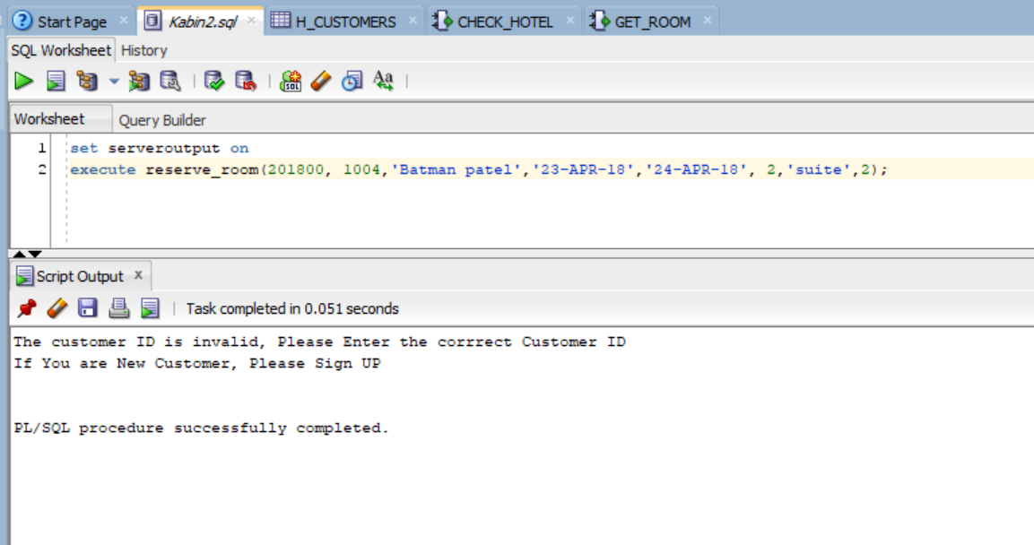

set serveroutput on

execute reserve_room(2018000, 1004,'Batman patel','23-APR-18','24-APR-18', 2,'conference',0);

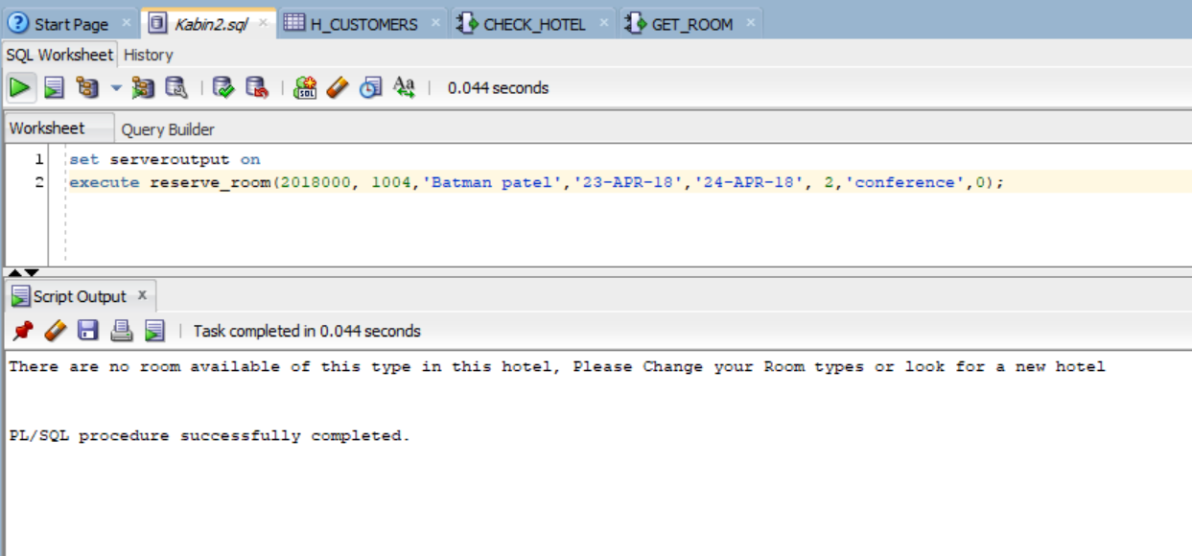

* 1. Find a reservation: Input is guest’s name and date, hotel ID. Output is reservation ID

--Procedure Created By Kabin Dulal

-- This procedure is used to find reservation

--Inputs are, Guest name, Reservation date and hotel Code and reservation code

--The output will be the reservation Number

--creating a process

create or replace procedure

findreservation(gname in Varchar2, re_date in date,ho_code in number,

re_code out number)

is

cursor c1 -- creating cursor to hold the data

is

select reservation_code into re_code --getting reservation code and inserting into re_code

from reservations

where

guest_name = gname and

reservation_date = re_date and

hotel_code = ho_code;

Rcode number;

x c1%rowtype;-- declaring row type to hold data

begin

select reservation_code into rcode --getting reservation code and inserting into re_code

from reservations

where

guest_name = gname and

reservation_date = re_date and

hotel_code = ho_code;

if rcode is null then

raise no_data_found;

else

open c1;

loop

fetch c1 into x;

exit when c1%NOTFOUND;--- exit condition

dbms_output.put_line('The reservation code is:'||' '||x.reservation_code);

end loop;

close c1;

end if;

exception

when no_data_found then

dbms_output.put_line('There are no reservation Exist');

end;

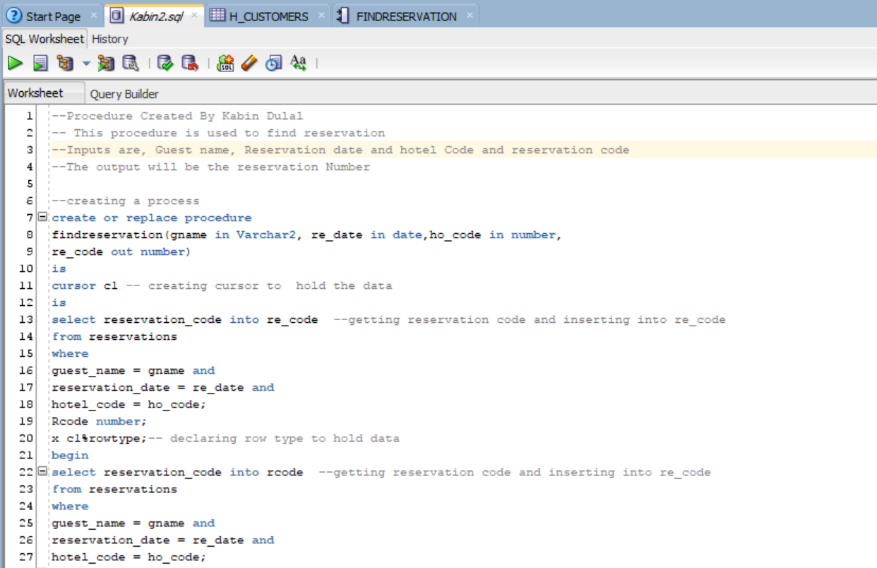

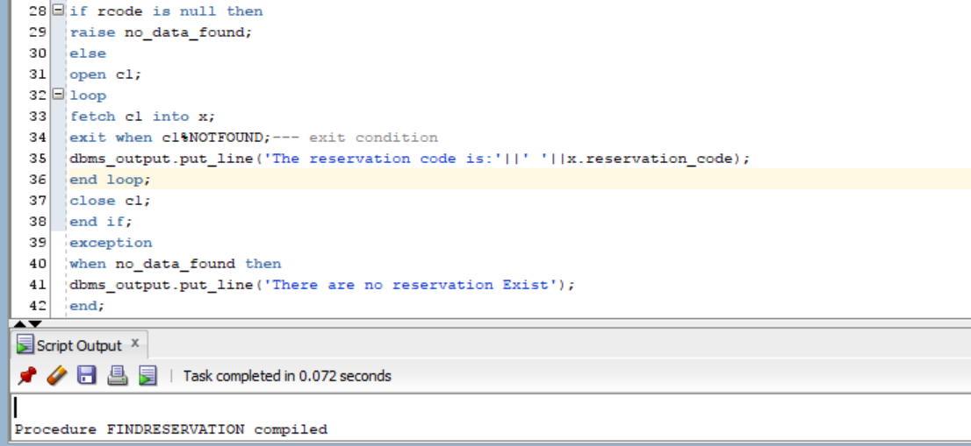

set SERVEROUTPUT ON

declare

re_code number;

begin

findreservation('Lihn Lam', '14-Apr-2018',1002, re_code);

dbms_output.put_line(re_code);

end;

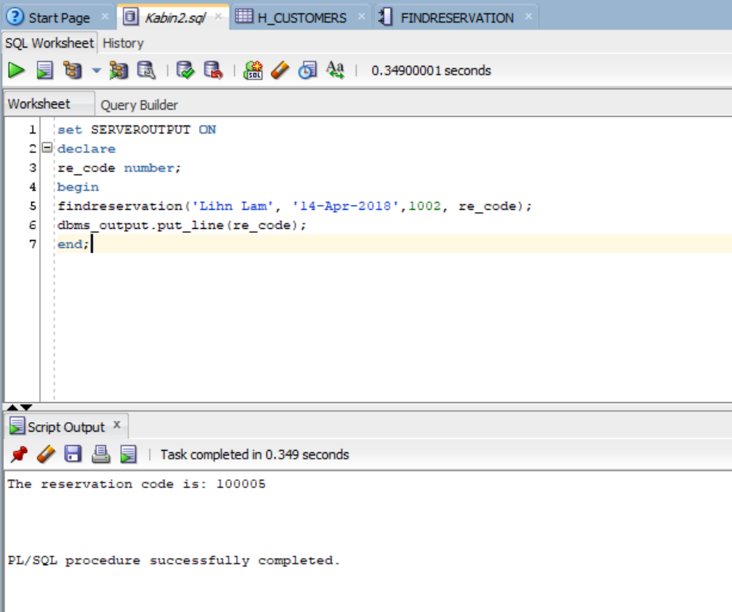

set SERVEROUTPUT ON

declare

re_code number;

begin

findreservation('Lihn Lam', '14-Apr-2018',102, re_code);

dbms_output.put_line(re_code);

end;

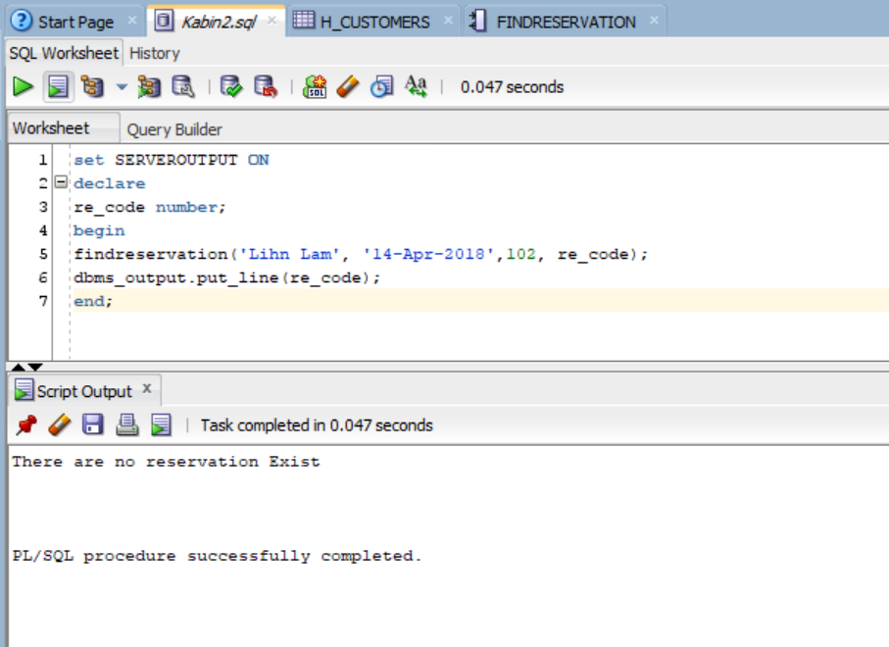

* 1. Cancel a reservation: Input the reservationID and mark the reservation as cancelled (do NOT delete it)

--Procedure Created By Kabin Dulal

-- This procedure is used to Cancle reservation

--Inputsis reservation code

--The output will be a confirmation message

--creating a process

**create** **or** **replace** **procedure** cancelreserrvation**(**re_code **in** **number)**--Giving parameter reservation code

**as**

r **number;**

**begin**

**select** reservation_code **into** r **from** reservations **where** RESERVATION_CODE**=**re_code**;** --checking if Reservation code is valid

**if** r **is** **null** **then**

**raise** no_data_found**;**

**else**

**UPDATE** RESERVATIONS

**set** Reservation_stat **=** 'Cancelled'

**where** reservation_code **=** re_code**;**

dbms_output**.**put_line**(**'Your reservation ' **||** Re_code**||**' canceled, sorry to seee you go'**);**-- display the confirmations

**end** **if;**

**exception**

**when** no_data_found **then**

dbms_output**.**put_line**(**'Reservation Code is invalid ' **);** --- display excepti

**end;**

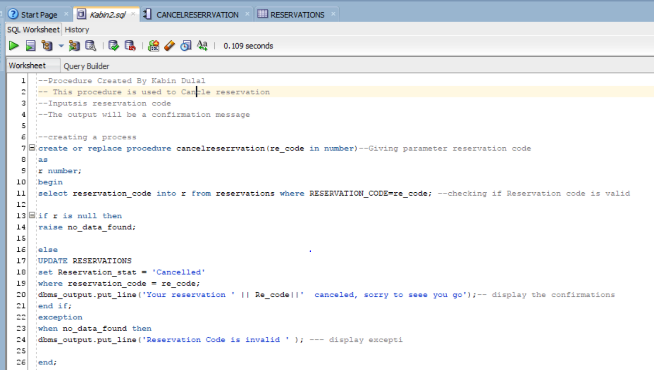

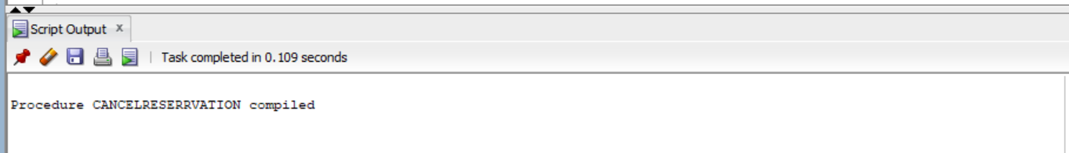

**set** serveroutput **on;**

**execute** cancelreserrvation**(**100001**);**

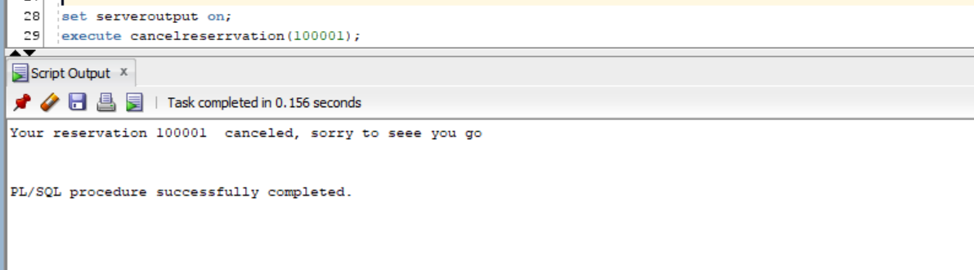

**set** serveroutput **on;**

**execute** cancelreserrvation**(**155121**);**

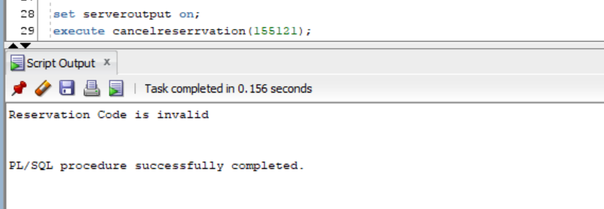

* 1. ShowCancelations: Print all canceled reservations in the hotel management system. Show reservation ID, hotel name, location, guest name, room type, dates

--Procedure Created By Kabin Dulal

-- This procedure is used to see all of the cancelled reservation

--Inputs none

--The output will be list of reservation with detail information

--creating a process

**create** **or** **replace** **procedure** show_cancellations-- creating procedure

**is**

**cursor** d1 **is**

**select** **distinct** r**.**reservation_stat**,**r**.**reservation_code**,** r**.**guest_name**,** r**.**check_in_date**,** r**.**Check_out_date**,** h**.**hotel_code**,** h**.**hotel_addr**,**

h**.**hotel_city**,** h**.**hotel_state**,** h**.**hotel_zip_code**,** r**.**room_code**,** RT**.**ROOM_DESC

**from** reservations R**,** hotels H**,** rooms rm**,** ROOM_TYPES RT

**where** r**.**Reservation_stat **=** 'Cancelled'

**and** r**.**hotel_code **=** H**.**hotel_code

**and** r**.**room_code**=** RM**.**room_code **and**

RM**.**room_type_code**=** RT**.**ROOM_TYPE_CODE**;**

excep **exception;**

**begin**

**for** a_c **in** d1

**loop**

**if** a_c**.**reservation_stat **<>** 'Cancelled'

**then**

**raise** excep**;**

**end** **if;**

dbms_output**.**put_line**(**'reservations_code:'**||**' '**||** a_c**.**reservation_code **);**

dbms_output**.**put_line**(**'hotel_code:'**||**' '**||** a_c**.**hotel_code **);**

dbms_output**.**put_line**(**'hotel_addr:'**||**' '**||** a_c**.**hotel_addr **||**', '**||** a_c**.**hotel_city **||**' '**||**

a_c**.**hotel_state **||**', '**||** a_c**.**hotel_zip_code **);**

dbms_output**.**put_line**(**'Guest_name:'**||**' '**||** a_c**.**guest_name **);**

dbms_output**.**put_line**(** 'room Number:'**||**' '**||** a_c**.**room_code **||**' Room type : '**||**a_c**.**room_desc **);**

dbms_output**.**put_line**(** 'Chech in date: '**||**' '**||** a_c**.**check_in_date **||**' Check Out date: '**||**a_c**.**Check_out_date **);**

dbms_output**.**put_line**(**'---------------------------------------------------------------'**);**

**end** **loop;**

**exception**

**when** excep **then**

dbms_output**.**put_line**(**'Either reservation is not cancelled or you enter wrong hotel code'**);**

**end;**

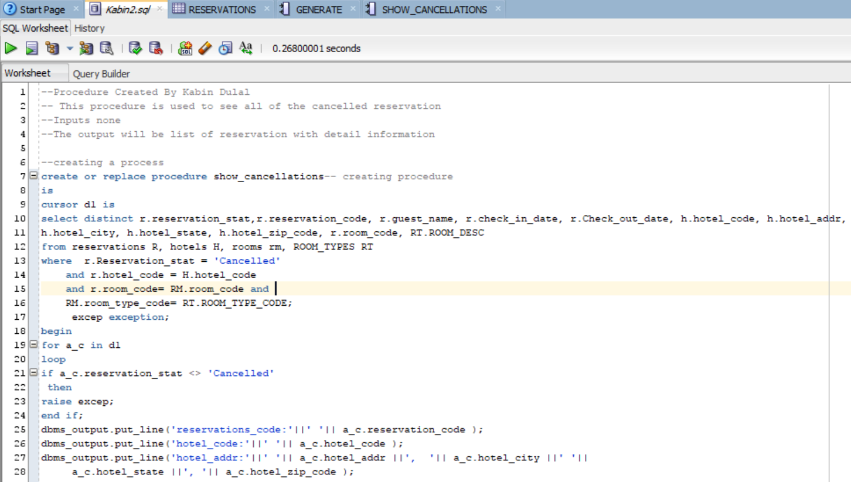

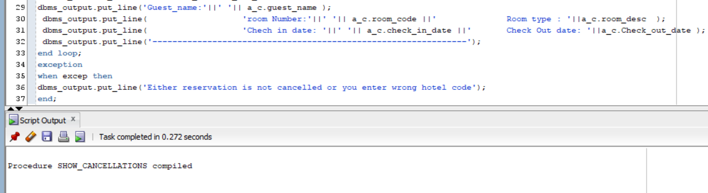

**set** SERVEROUTPUT **ON**

**execute** show_cancellations**;**

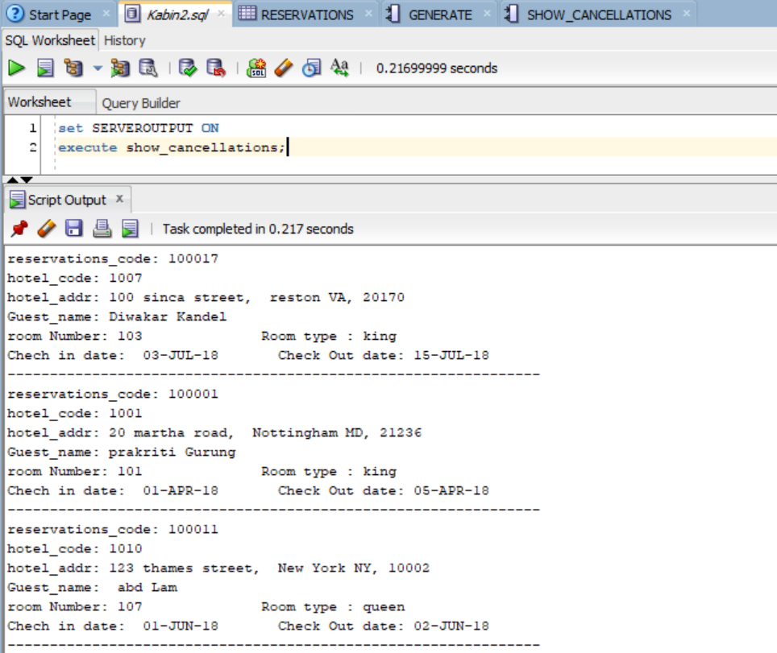

* Member 3: Diwakar Sharma
  1. Change a reservationDate: Input the reservation ID and change reservation start and end date, if there is availability in the same room type for the new date interval

--Procedure Created By diwakar Sharma

-- This procedure is used to change the reservation

--Inputs Reservation Code, new check in date, new check out date

--The output will be

--creating a process

**create** **or** **replace** **procedure** change_reserve**(**re_code **in** **number,** in_date **in** **date,**

out_date **in** **date)**

**as**

**begin**

**UPDATE** RESERVATIONS

**set** CHECK_IN_DATE **=** in_date**,**

CHECK_OUT_DATE **=** out_date

**where** reservation_code **=** re_code**;**

dbms_output**.**put_line**(**'date changed for the reservation:'**||**' '**||**re_code**);**

dbms_output**.**put_line**(**'check in date:'**||**' '**||**in_date**||**' '**||**'check out date:'**||**' '**||**out_date**);**

**commit;**

**exception**

**when** **others** **then**

dbms_output**.**put_line**(**'An Error Occured'**);**

**rollback;**

**end;**

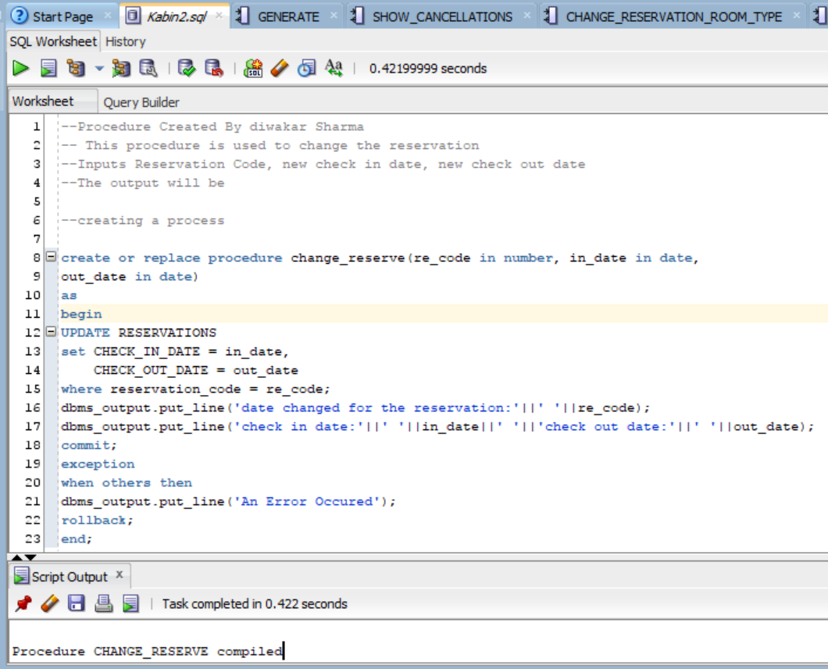

**set** serveroutput **on;**

**execute** change_reserve**(**100002**,** '03-JUN-18'**,** '04-JUN-18'**);**

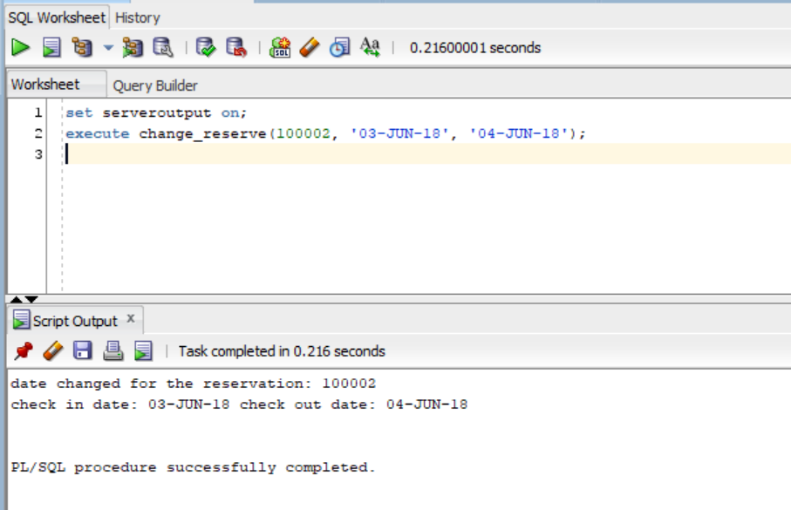

* 1. Change a reservationRoomType: Input the reservation ID and change reservation room type if there is availability for that room type during the reservation’s date interval

--Procedure Created By diwakar Sharma

-- This procedure is used to change room Type in reservation

--Inputs Reservation Code, and new room Type

--The output will be a confirmation message or an exception message

--creating a process

**create** **or** **replace** **procedure** change_reservation_room_type **(**r_code **in** **number,** room_d **varchar2)** -- create new procedure

**as**

room_num ROOMS**.**HOTEL_CODE**%type;** -- variables to store data

indate RESERVATIONS**.**CHECK_IN_DATE**%type;**

outdate RESERVATIONS**.**CHECK_OUT_DATE**%type;**

Hotel_c RESERVATIONS**.**HOTEL_CODE**%type;**

**begin**

**select** check_in_date **into** indate **from** reservations **where** reservation_code**=** r_code**;**

**select** check_out_date **into** outdate **from** reservations **where** reservation_code**=** r_code**;**

**select** hotel_code **into** hotel_c **from** reservations **where** reservation_code**=** r_code**;**

**select** r**.**room_code **into** room_num **from** rooms R**,** room_types RT **where** -- sql statement

RT**.**room_desc **=** room_d **and**

R**.**Room_status **=** 'open' **and**

R**.**hotel_code **=** hotel_c **and**

RT**.**room_type_code **=** R**.**Room_type_code **And**

R**.**room_code **not** **in** **(select** room_code **from** RESERVATIONS

**where** check_in_date **=** indate **and**

check_out_date **=** Outdate **and**

reservation_stat **=** 'Booked'**)** **and**

**rownum** **<**2**;**

**update** reservations

**set** room_Code **=** room_num

**where** reservation_code **=** r_code**;**

DBMS_OUTPUT**.**PUT_LINE**(**'Your room type has been changed to '**||**room_d **||**'Your new room_number is '**||**room_num**);**

**exception** -- it calls exception

**when** no_data_found **then**

DBMS_OUTPUT**.**PUT_LINE**(**'no room availabel please change your search criteria'**);**

**end;**

**set** SERVEROUTPUT **ON**

**begin**

change_reservation_room_type **(**100043**,** 'king'**);**

**end;**

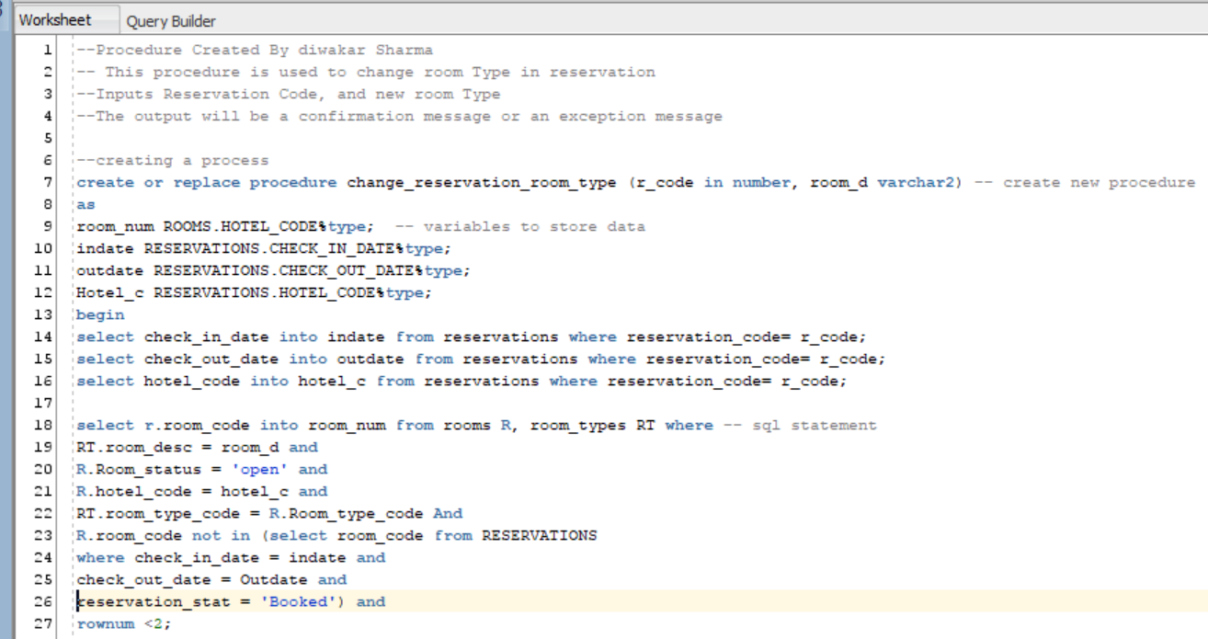

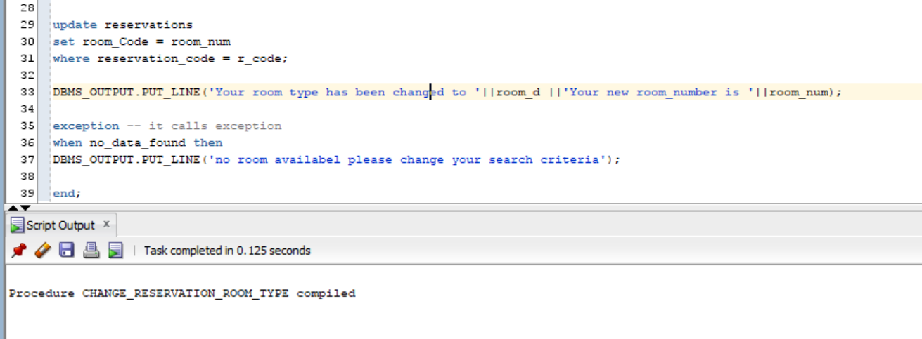

**set** SERVEROUTPUT **ON**

**begin**

change_reservation_room_type **(**100043**,** 'king'**);**

**end;**

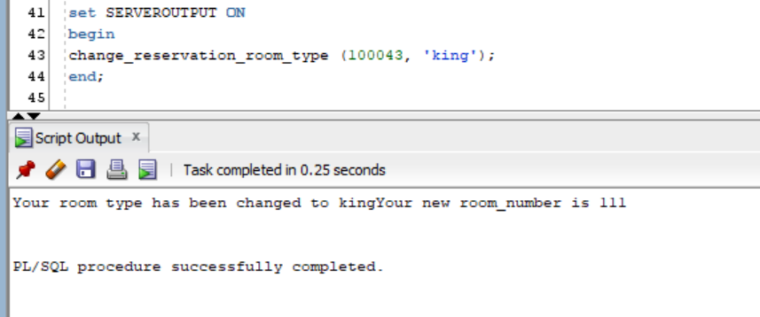

**set** SERVEROUTPUT **ON**

**begin**

change_reservation_room_type **(**100043**,** 'conference'**);**

**end;**

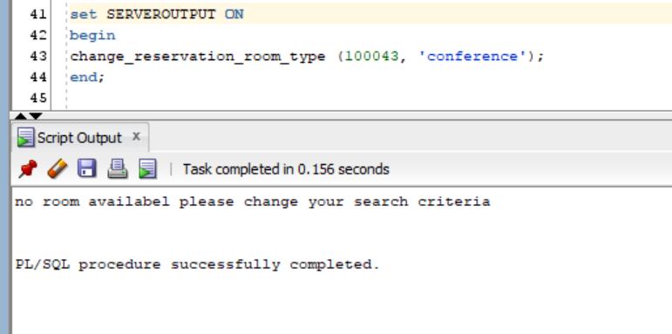

* 1. Show single hotel reservations: Given a hotel ID, show all reservations for that hotel

--Procedure Created By diwakar Sharma

-- This procedure is used to view all of the reservation of the single hotel

--Inputs is hotel code

--The output will be list of reservation of the hotel

**create** **or** **replace** **procedure** show_reservations**(**h_code **number)**

**is**

**cursor** c1

**is**

**select** **\*** **from** reservations **where**

hotel_code **=** h_code**;**

r2 c1**%rowtype;**

rc **number;**

excep **exception;**

**begin**

**select** **distinct** hotel_code **into** rc **from** reservations **where** hotel_code **=** h_code**;**

**if** rc **<**1 **then**

**raise** no_data_found**;**

**else**

**open** c1**;**

**loop**

**fetch** c1 **into** r2**;**

**exit** **when** c1**%**notfound**;**

dbms_output**.**put_line**(**'reservation_code: '**||** r2**.**reservation_code**);**

dbms_output**.**put_line**(**'guest_name: '**||** r2**.**guest_name**);**

dbms_output**.**put_line**(**'check_in_date: '**||** r2**.**check_in_date**);**

dbms_output**.**put_line**(**'check_out_date: '**||** r2**.**check_out_date**);**

dbms_output**.**put_line**(**'reservation_date: '**||** r2**.**reservation_date**);**

dbms_output**.**put_line**(**'no_of_guests: '**||** r2**.**no_of_guests**);**

dbms_output**.**put_line**(**'customer_code: '**||** r2**.**customer_code**);**

dbms_output**.**put_line**(**'hotel_code: '**||** r2**.**hotel_code**);**

dbms_output**.**put_line**(**'room_code: '**||** r2**.**room_code**);**

dbms_output**.**put_line**(**'reservation status: '**||** r2**.**reservation_stat**);**

dbms_output**.**put_line**(**'------------------------------------------------------'**);**

**end** **loop;**

**close** c1**;**

**end** **if;**

**exception**

**when** no_data_found **then**

dbms_output**.**put_line**(**'this is wrong hotel code, Please enter tghe correct Hotel ID'**);**

**end;**

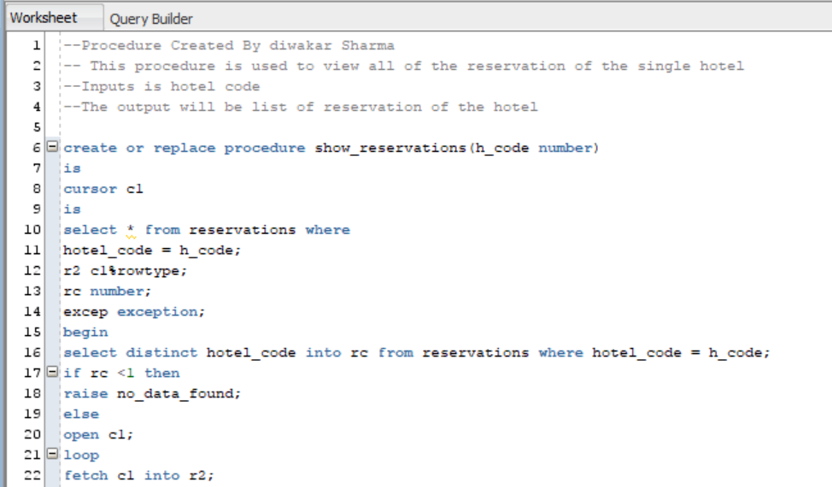

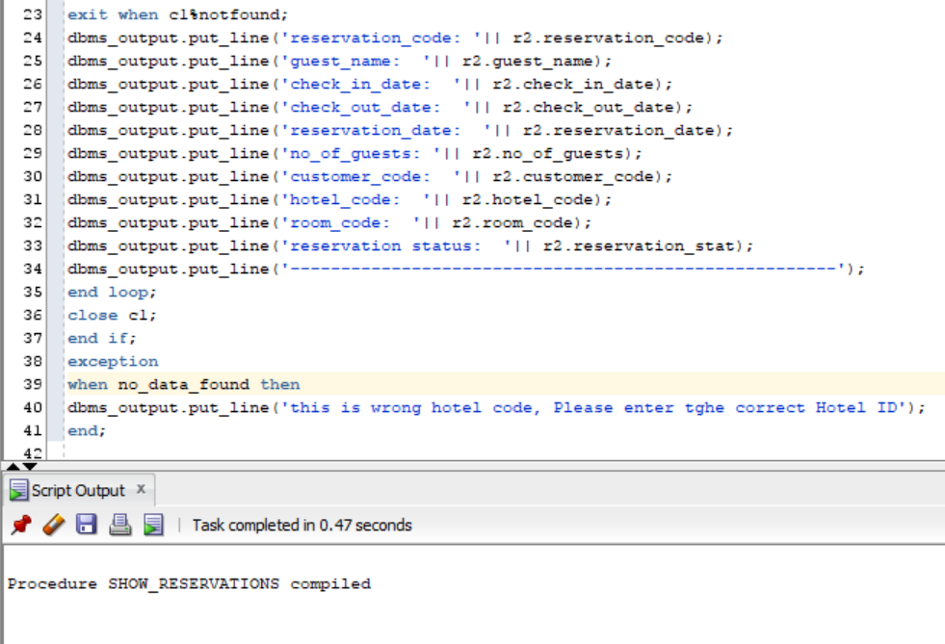

**set** serveroutput **on**

**exec** show_reservations**(**'1005'**)**

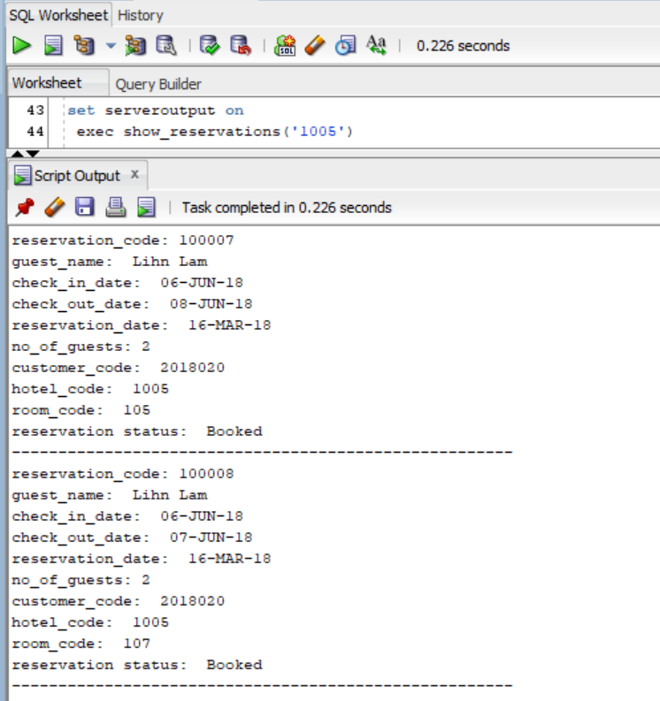

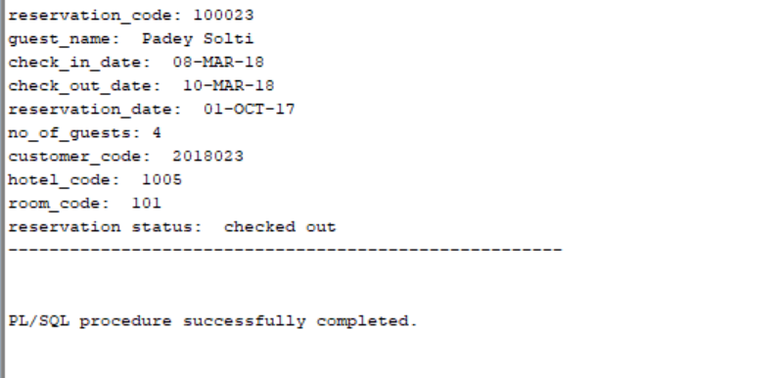

**set** serveroutput **on**

**exec** show_reservations**(**'105'**)**

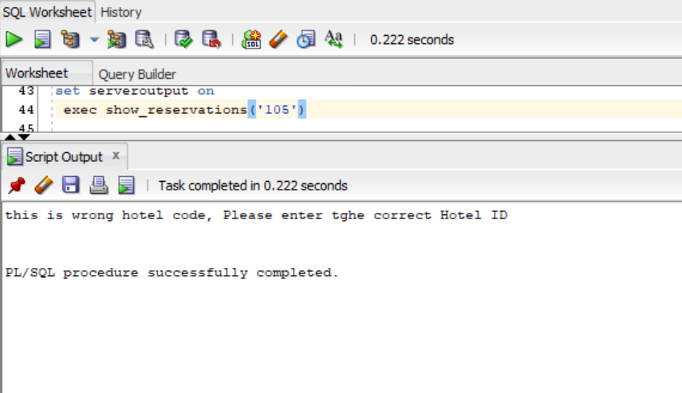

* 1. Show single guest reservations: Given a guest name, find all reservations under that name

--Procedure Created By diwakar Sharma

-- This procedure is used to view all of the reservation of the single customer/guest

--Inputs is Guest name

--The output will be list of reservation of a single guest

**create** **or** **replace** **procedure** find_guest_reservation**(**g_name **Varchar2)**

**is**

**cursor** c1

**is**

**select** **\*** **from** reservations **where**

guest_name **=** g_name**;**

r2 c1**%rowtype;**

Gname **varchar2(**60**);**

**begin**

**select** **distinct** guest_name **into** Gname **from** reservations **where** guest_name **=**g_name**;**

**if** gname **is** **null** **then**

**raise** no_data_found**;**

**end** **if;**

**open** c1**;**

**loop**

**fetch** c1 **into** r2**;**

**EXIT** **WHEN** c1**%**notFound**;**

dbms_output**.**put_line**(**'reservation_code '**||** r2**.**reservation_code**);**

dbms_output**.**put_line**(**'guest_name '**||** r2**.**guest_name**);**

dbms_output**.**put_line**(**'check_in_date '**||** r2**.**check_in_date**);**

dbms_output**.**put_line**(**'check_out_date '**||** r2**.**check_out_date**);**

dbms_output**.**put_line**(**'reservation_date '**||** r2**.**reservation_date**);**

dbms_output**.**put_line**(**'no_of_guests'**||** r2**.**no_of_guests**);**

dbms_output**.**put_line**(**'customer_code '**||** r2**.**customer_code**);**

dbms_output**.**put_line**(**'hotel_code '**||** r2**.**hotel_code**);**

dbms_output**.**put_line**(**'room_code '**||** r2**.**room_code**);**

dbms_output**.**put_line**(**'reservation_stat '**||** r2**.**reservation_stat**);**

dbms_output**.**put_line**(**'----------------------------------------------------------------'**);**

**end** **loop;**

**close** c1**;**

**exception**

**when** no_data_found **then**

dbms_output**.**put_line**(**'it is not guest name'**);**

**end;**

**set** serveroutput **on;**

**execute** find_reservation_total**(**'ABC Lam'**);**

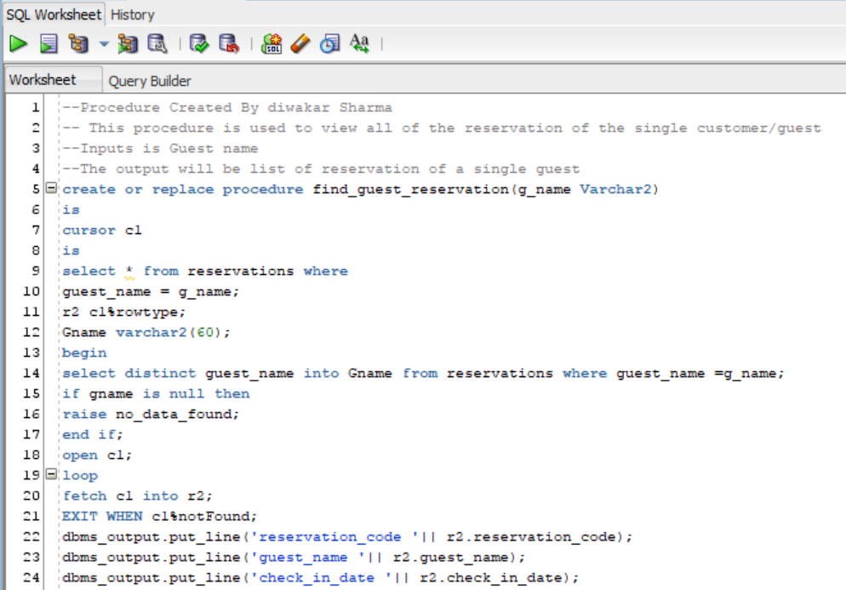

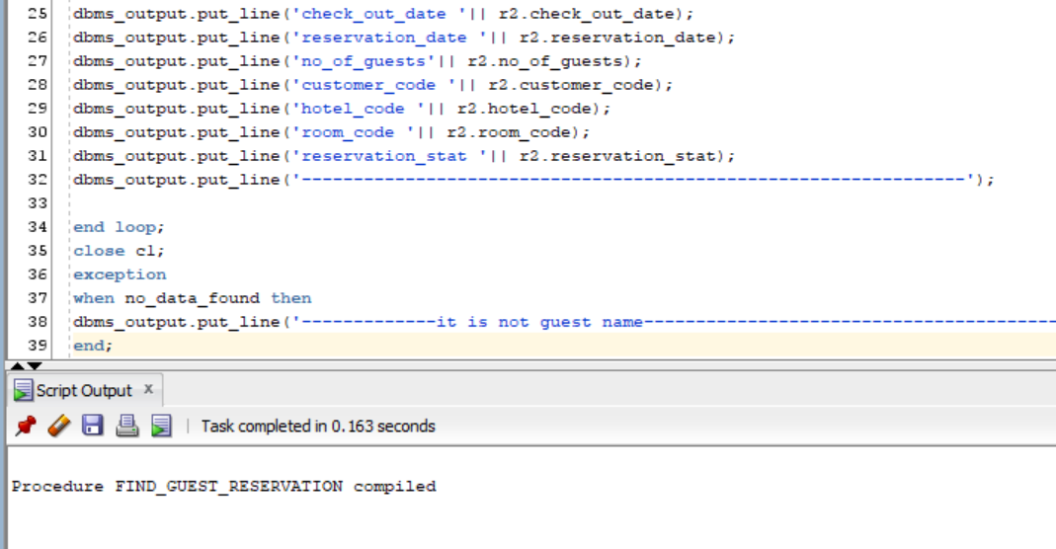

**set** serveroutput **on;**

**execute** find_guest_reservation**(**'Lihn Lam'**);**

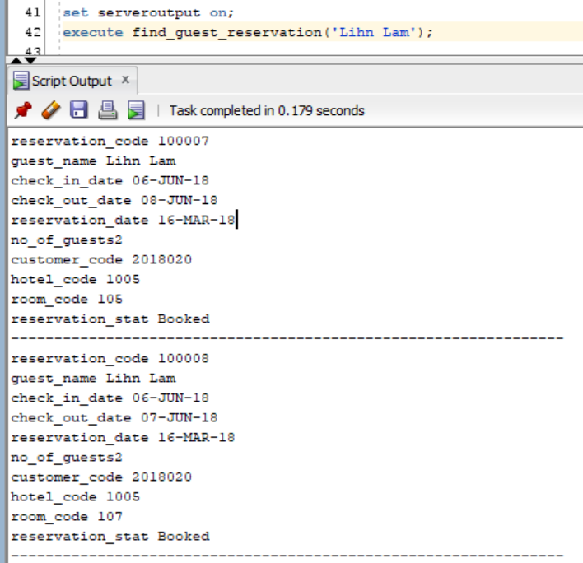

**set** serveroutput **on;**

**execute** find_guest_reservation**(**'AAA Lam'**);**

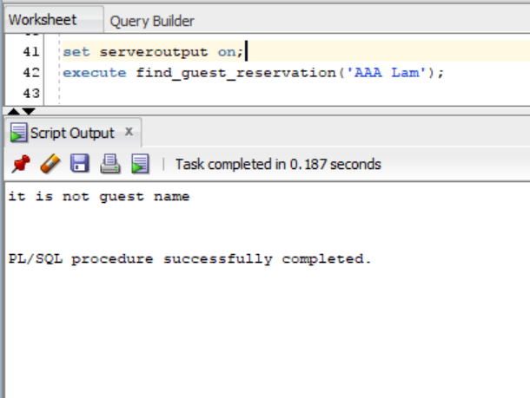

* 1. Total Monthly Income Report: Calculate and display total income from all sources of all hotels. Totals must be printed by month, and for each month by room type, service type. Include discounts.

--Procedure Created By diwakar Sharma

-- This procedure is used to view report by month

--Inputs none

--The output will be list of monthly report

**create** **or** **replace** **procedure** Monthly_report

**is**

**cursor** c1 **is** -- this cursor gives information about first month income

**Select** **sum(**room_charge**)as** R_revenue**,** **Sum(**discount**)** **as** Discount **,**room_desc **from** room_income **where** **month=**1 **group** **by** room_desc**;**

**cursor** c2 **is** -- this cursor gives information about first mont service

**select** **sum(**service_rate**)** **as** S_revenue**,** service_desc **from** service_income **where** **month=**1 **group** **by** SERVICE_DESC**;**

**cursor** c3 **is**---- this cursor gives information about second month income

**Select** **sum(**room_charge**)as** R_revenue**,** **Sum(**discount**)** **as** Discount **,**room_desc **from** room_income **where** **month=**2 **group** **by** room_desc**;**

**cursor** c4 **is**---- this cursor gives information about second month service

**select** **sum(**service_rate**)** **as** S_revenue**,** service_desc **from** service_income **where** **month=**2 **group** **by** SERVICE_DESC**;**

**cursor** c5 **is**-- third month

**Select** **sum(**room_charge**)as** R_revenue**,** **Sum(**discount**)** **as** Discount **,**room_desc **from** room_income **where** **month=**3 **group** **by** room_desc**;**

**cursor** c6 **is**--third month

**select** **sum(**service_rate**)** **as** S_revenue**,** service_desc **from** service_income **where** **month=**3 **group** **by** SERVICE_DESC**;**

R1 c1**%rowtype;** -- they store cursor information

R2 C2**%rowtype;**

R3 c3**%rowtype;**

R4 C4**%rowtype;**

R5 c5**%rowtype;**

R6 C6**%rowtype;**

**Begin**

**open** c1**;**

dbms_output**.**put_line **(**'--------------Monthly Sales Report----------------'**);**

dbms_output**.**put_line **(**'---------------------------------------------------'**);**

dbms_output**.**put_line **(**'--------------Report for JANUARY----------------'**);**

dbms_output**.**put_line **(**'--------Rooms--------'**);**

**loop**

**fetch** c1 **into** R1**;** **exit** **when** c1**%**notfound**;**

dbms_output**.**put_line **(**R1**.**room_desc**||**' $'**||** r1**.**R_revenue**);**

**end** **loop;**

**close** c1**;**

**open** c2**;**

dbms_output**.**put_line **(**'--------Services---------'**);**

**loop**

**fetch** c2 **into** r2**;** **exit** **when** c2**%**notfound**;**

dbms_output**.**put_line **(**R2**.**service_desc**||**' $'**||** R2**.**S_revenue**);**

**end** **loop;** **close** c2**;**

**open** c3**;**

dbms_output**.**put_line **(**'--------------Report for FEBREARY----------------'**);**

dbms_output**.**put_line **(**'--------Rooms--------'**);**

**loop**

**fetch** c3 **into** R3**;** **exit** **when** c3**%**notfound**;**

dbms_output**.**put_line **(**R3**.**room_desc**||**' $'**||**r3**.**R_revenue**);**

**end** **loop;** **close** c3**;**

**open** c4**;**

dbms_output**.**put_line **(**'--------Services---------'**);**

**loop**

**fetch** c4 **into** r4**;** **exit** **when** c4**%**notfound**;**

dbms_output**.**put_line **(**R4**.**service_desc **||**' $'**||**R4**.**S_revenue**);**

**end** **loop;** **close** c4**;**

**open** c5**;**

dbms_output**.**put_line **(**'--------------Report for MARCH----------------'**);**

dbms_output**.**put_line **(**'--------Rooms--------'**);**

**loop**

**fetch** c5 **into** r5**;** **exit** **when** c5**%**notfound**;**

dbms_output**.**put_line **(**R5**.**room_desc **||**' $'**||**R5**.**r_revenue**);**

**end** **loop;** **close** c5**;**

**open** c6**;**

dbms_output**.**put_line **(**'--------Services---------'**);**

**loop**

**fetch** c6 **into** r6**;** **exit** **when** c6**%**notfound**;**

dbms_output**.**put_line **(**R6**.**service_desc**||**' $'**||** R6**.**S_revenue**);**

**end** **loop;** **close** c6**;**

**end;**

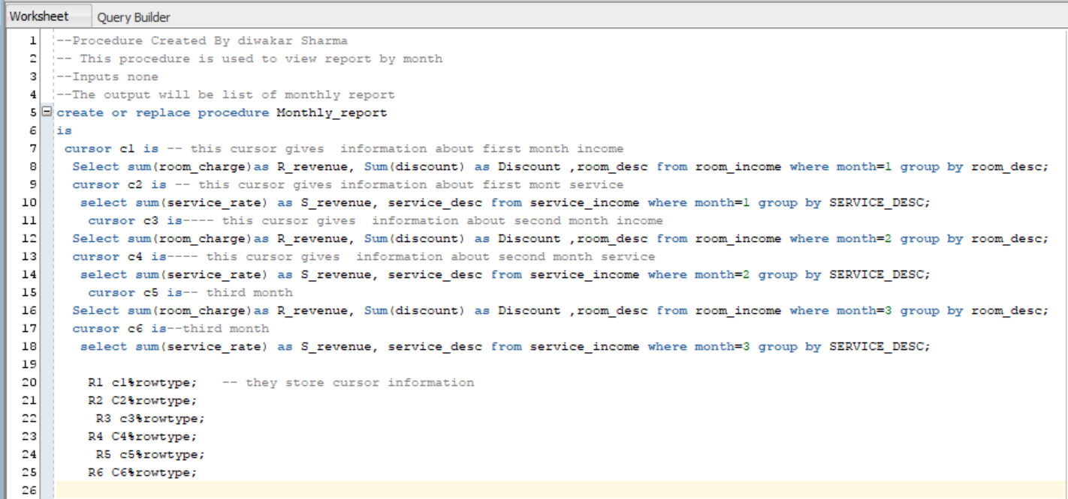

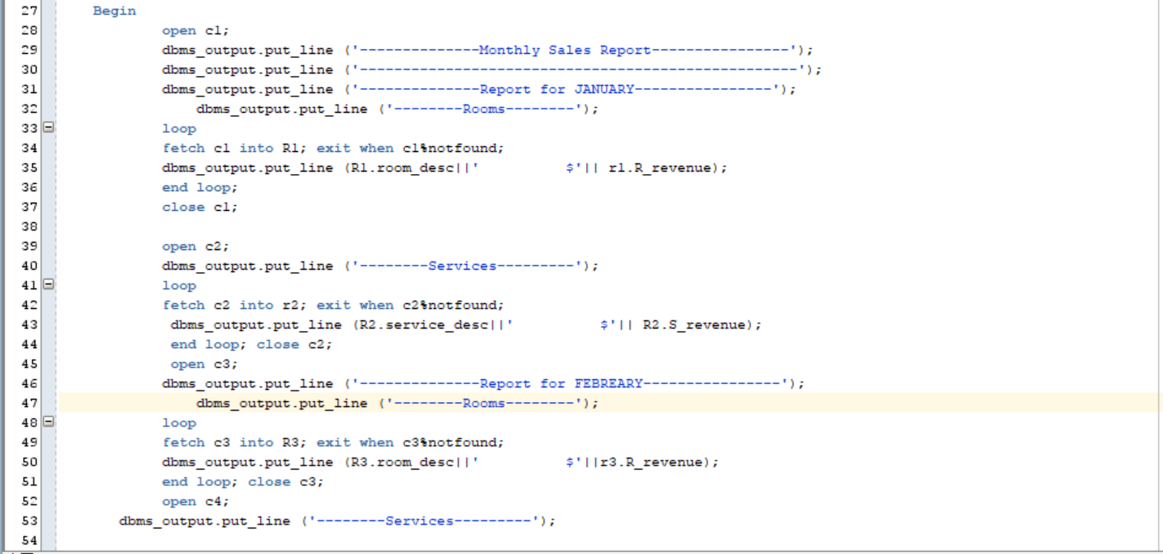

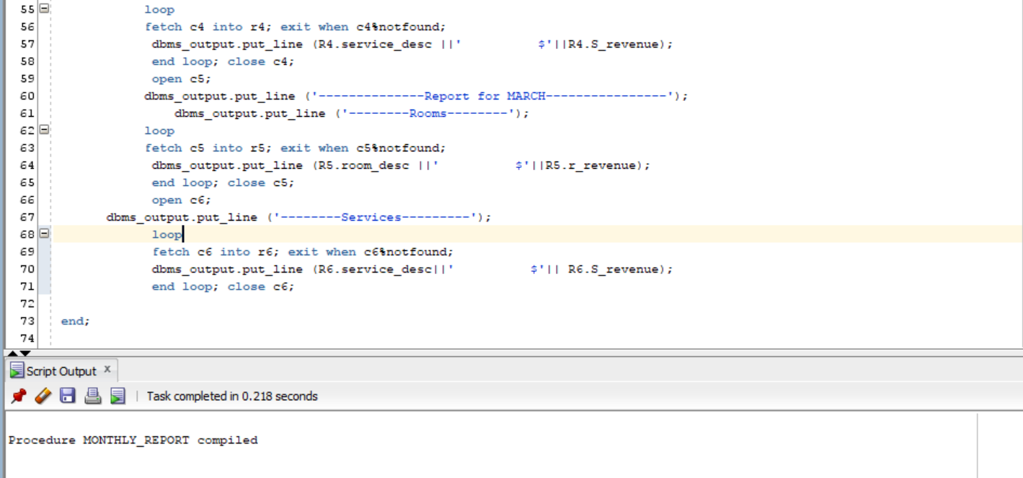

**set** SERVEROUTPUT **ON**

**execute** Monthly_report**;**

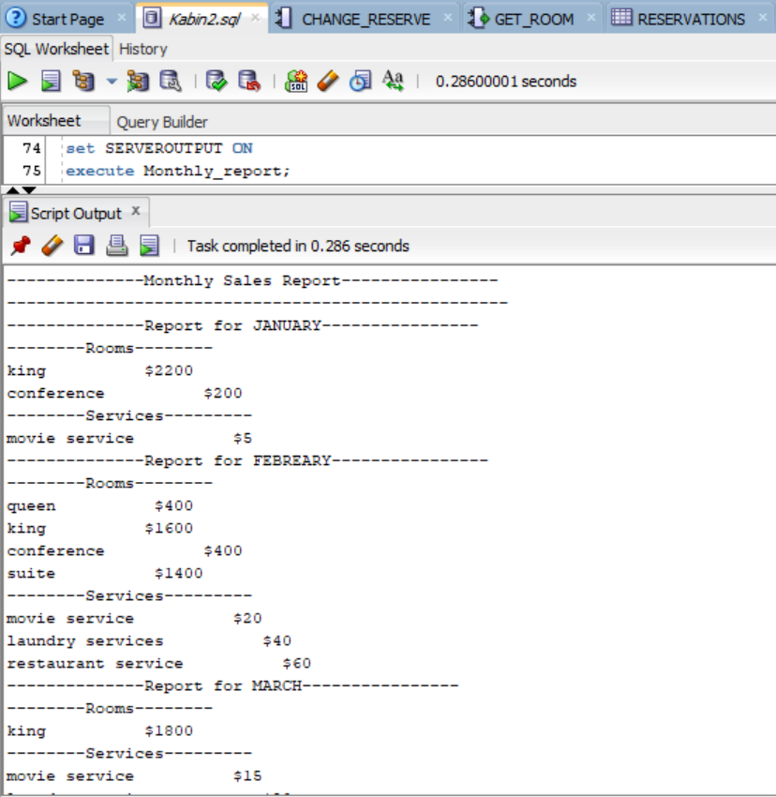

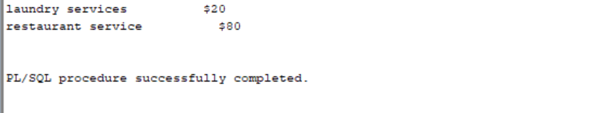

Member 4: Split

* 1. Add a service to a reservation: Input: ReservationID, specific service. Add the service to the reservation for a particular date. Multiple services are allowed on a reservation for the same date.

**---------------------Kabin Dulal-------------------------**

--Procedure Created By Kabin Dulal

-- This procedure is used to add a service to a reservation

--Inputs reservation code, new service code

--The output will be a confirmation message/error message

**create** **or** **replace** **Procedure** Add_service **(**r_code **in** **Number,** S_code **in** **number)** -- create procedure

**is** --- variable decleration

Cur_code **number;**

new_code **number;**

Sname **varchar(**50**);**

ch_r **number;**

No_service **exception;**

No_r **exception;**

**Begin**

--generating new code

**select** **max(**service_p_code**)** **into** cur_code **from** SERVICE_PERFORMED**;**

new_code**:=**cur_code +1**;**

--getting Service name

**Select** service_desc **into** sname **from** room_services **where** SERVICE_CODE**=**S_code**;**

**if** sname **is** **null** **then**

**raise** no_data_found**;**

**end** **if;**

--checking reservation

**select** reservation_code **into** Ch_r **from** reservations **where** RESERVATION_CODE**=**R_code**;**

--if not valid

**if** ch_r **is** **null** **then**

**raise** no_data_found**;**

**end** **if;**

**insert** **into** SERVICE_PERFORMED **values** **(**New_code**,**s_code**,**R_code**,** **sysdate);**

DBMS_OUTPUT**.**PUT_LINE**(**'Service '**||**s_code**||**'('**||**Sname**||**') added to reservation '**||**r_code**);**

**exception**

**when** no_data_found **then**

DBMS_OUTPUT**.**PUT_LINE**(**'The inputs are invalid'**);**

**end;**

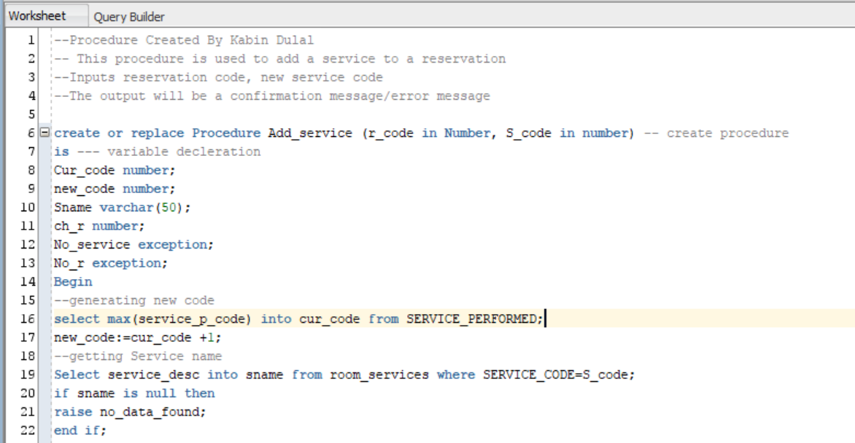

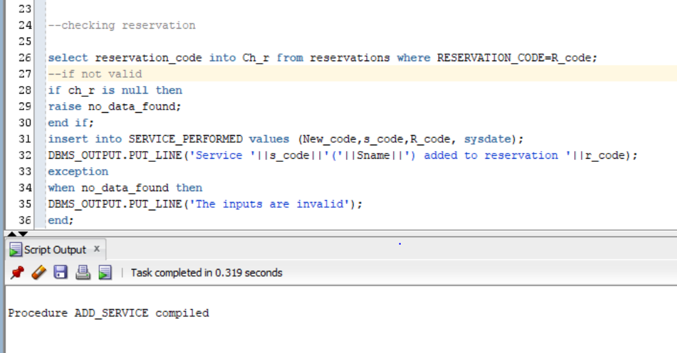

**Set** SERVEROUTPUT **ON**

**execute** add_service**(**100012**,**200**);**

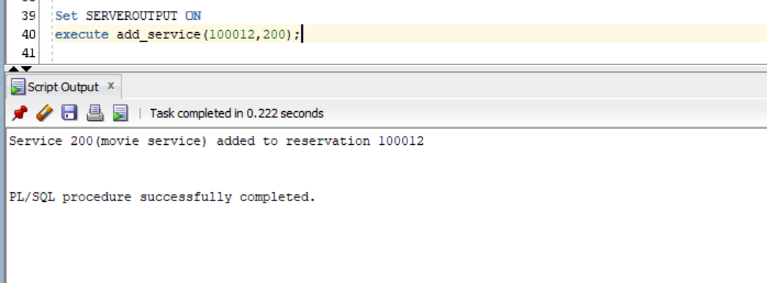

**Set** SERVEROUTPUT **ON**

**execute** add_service**(**1012**,**200**);**

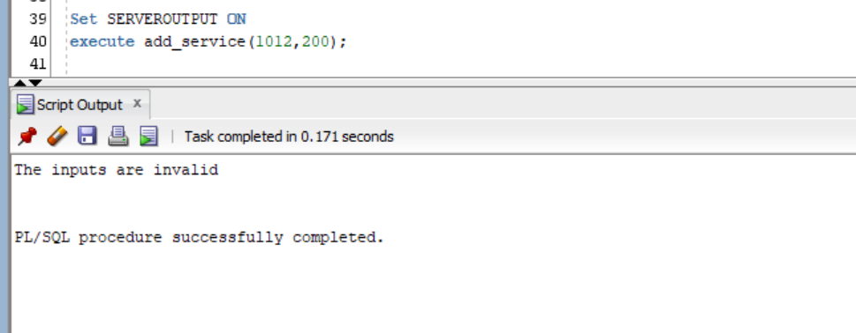

* 1. Reservation Services Report: Input the reservation ID and display all services on this reservation. Print “no services for this reservation” if none exists.

**--------------------Diwakar Sharma-------------------------**

--Procedure Created By diwakar Sharma

-- This procedure is used to display all services in a reservation

--Inputs reservation code

--The output will display the services in a reservation

**create** **or** **replace** **Procedure** View_services **(**r_code **in** **Number)**

**is**

**cursor** c1 **is**

**select** SP**.**service_P_code**,** SP**.**SERVICE_DATE**,** RS**.**SERVICE_DESC **from** service_performed SP**,** Room_services RS

**where** reservation_code**=**r_code **and** SP**.**service_code**=**RS**.**SERVICE_CODE**;**

RT c1**%rowtype;**

excep **EXCEPTION;**

r **number;**

**begin**

**select** reservation_code **into** r **from** reservations **where** reservation_code**=**r_code**;**

**open** c1**;**

**loop**

**fetch** c1 **into** RT**;**

**exit** **when** c1**%**notfound**;**

DBMS_OUTPUT**.**PUT_LINE**(**'Perform_code: '**||**RT**.**service_p_code**||**' | Service Date: '**||**RT**.**service_date**||**' | Service Description: '**||**RT**.**service_desc**);**

**end** **loop;**

**close** c1**;**

**exception**

**when** no_data_found **then**

DBMS_OUTPUT**.**PUT_LINE**(**'There are no services Performed for this reservation, Or the reservation is invalid '**);**

**end;**

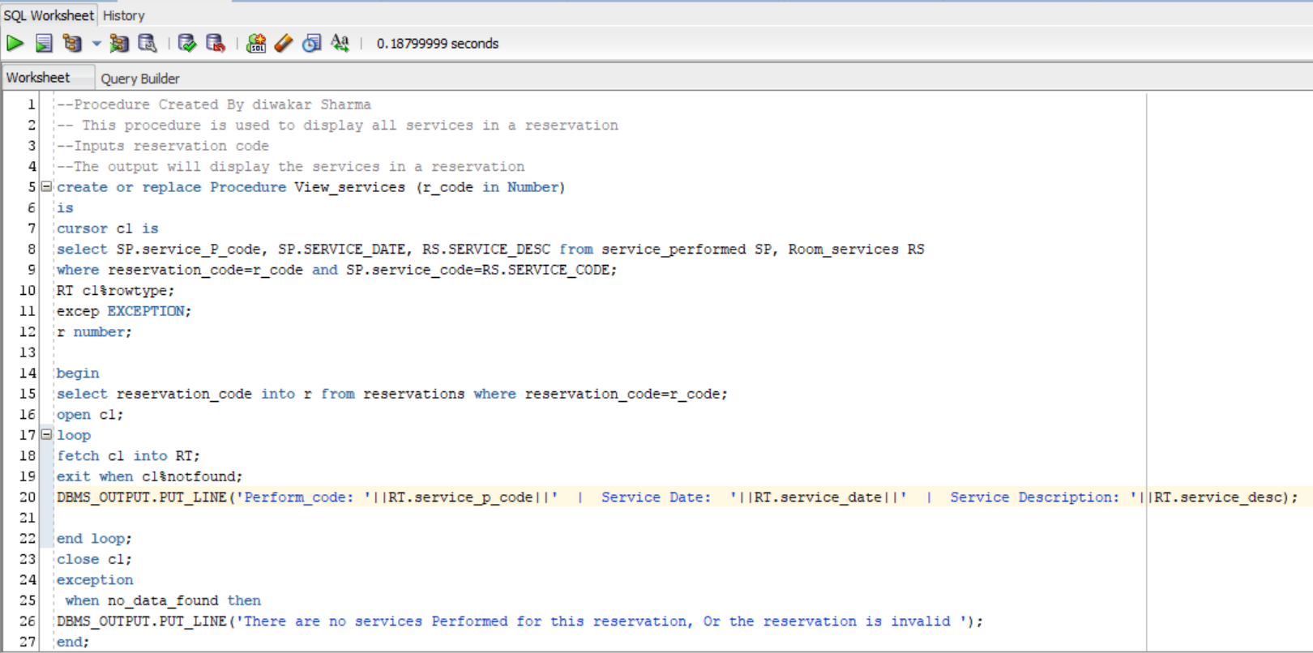

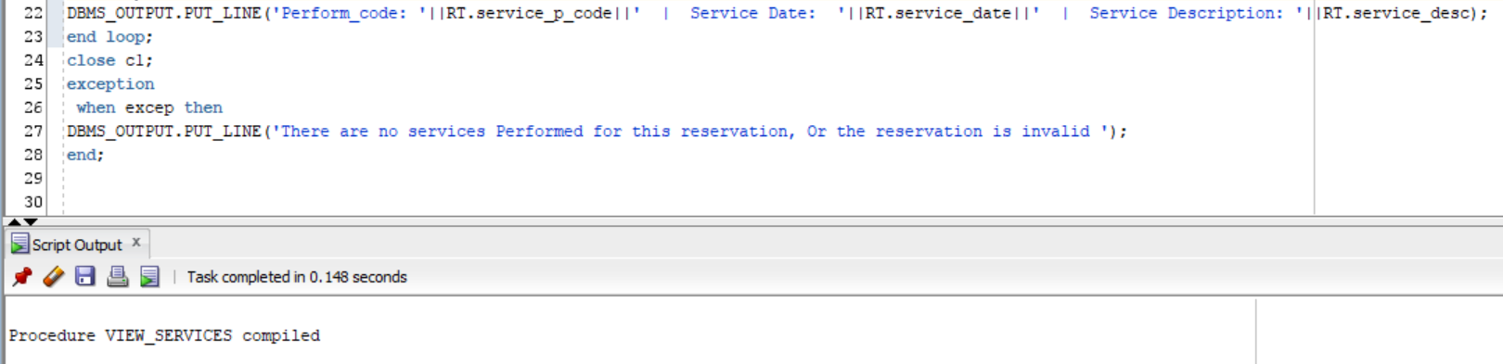

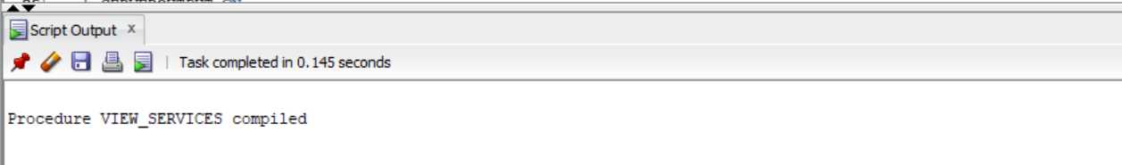

**set** SERVEROUTPUT **ON**

**execute** view_services**(**100001**);**

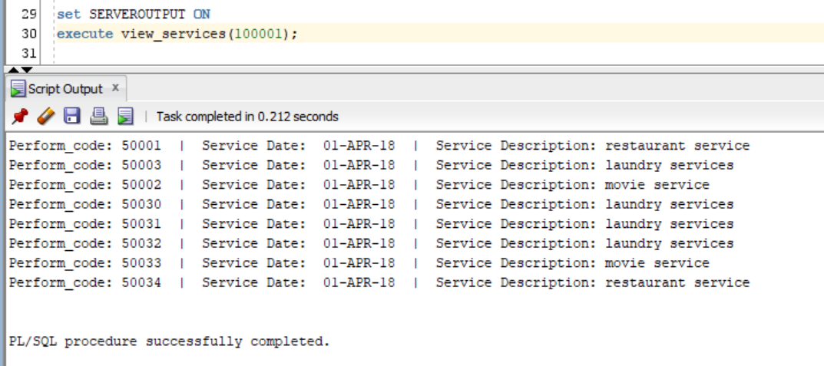

**set** SERVEROUTPUT **ON**

**execute** view_services**(**1121**);**

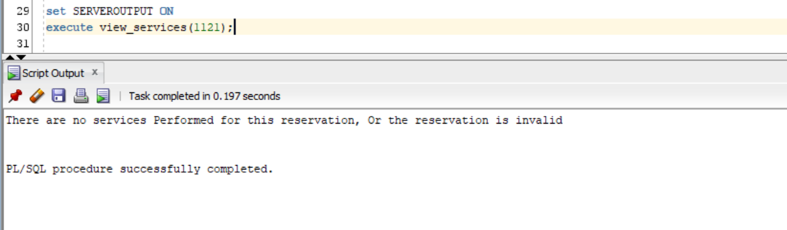

* 1. Show Specific Service Report: Input the service name, and display information on all reservations that have this service in all hotels

**---------------------Sijan karki-------------------------**

--Procedure Created By Sijan Karki

-- This procedure is used to view specific service report

--Inputs none

--The output will be a single service with its information

**create** **or** **replace** **Procedure** service_report**(**s_name **in** **varchar2)** --creating a process

**is**

**cursor** c1 **is**

**select** rs**.**service_code**,** rs**.**service_desc**,** r**.**reservation_code**,** sp**.**service_date**,** r**.**hotel_code

**from** room_services rs**,** Service_performed sp**,** reservations r

**where** rs**.**service_desc**=** s_name **and**

rs**.**service_code**=**sp**.**service_code **and**

sp**.**reservation_code **=**r**.**reservation_code

**order** **by** r**.**hotel_code**;**

x c1**%rowtype;**

**begin**

**open** c1**;**

dbms_output**.**put_line**(**'SERVICE PERFORMED REPORT'**);**

dbms_output**.**put_line**(**s_name**);**

**loop**

**fetch** c1 **into** x**;** --c1 is fetched into x

**exit** **when** c1**%**notfound**;**

dbms_output**.**put_line**(**'Service code: '**||** x**.**service_code **||**' | Reservation_code: '**||**x**.**reservation_code**||**

' | Service date: '**||** x**.**service_date**||**' | Hotel Code: '**||**x**.**hotel_code**);**

**end** **loop;**

**close** c1**;**

**end;**

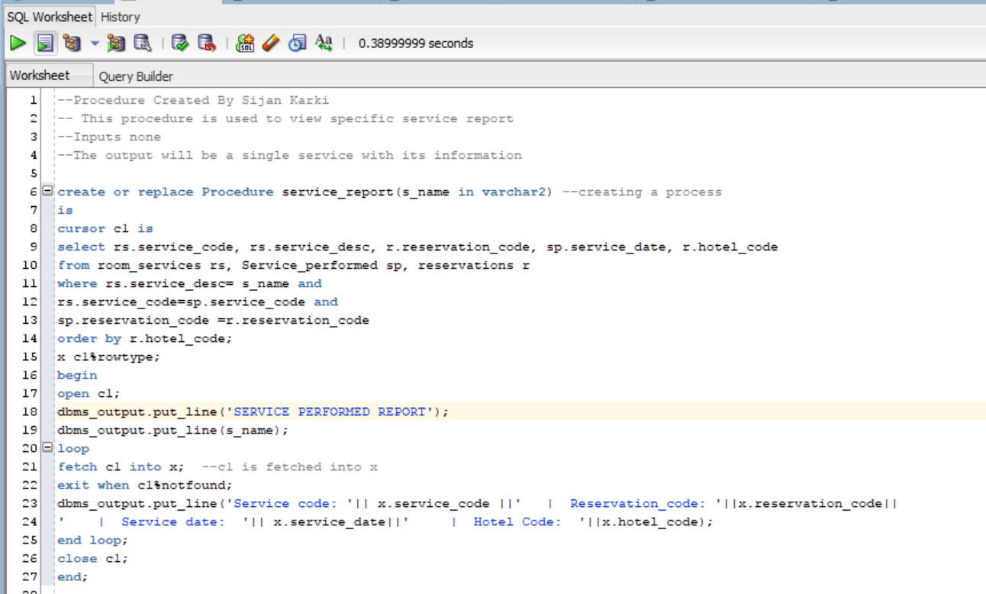

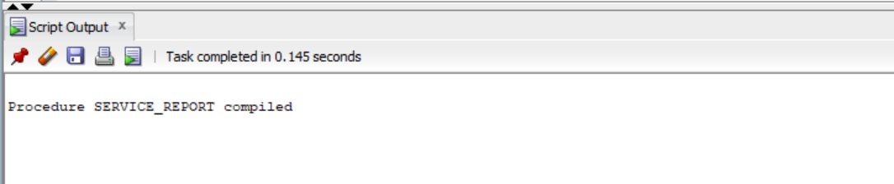

**set** SERVEROUTPUT **ON**

**execute** SERVICE_REPORT**(**'movie service'**)**

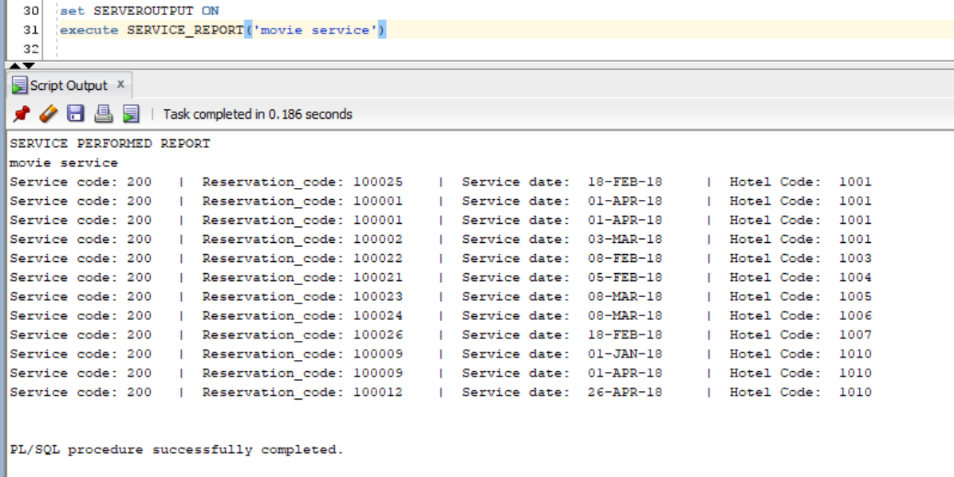

**set** SERVEROUTPUT **ON**

**execute** SERVICE_REPORT**(**'restaurant service'**)**

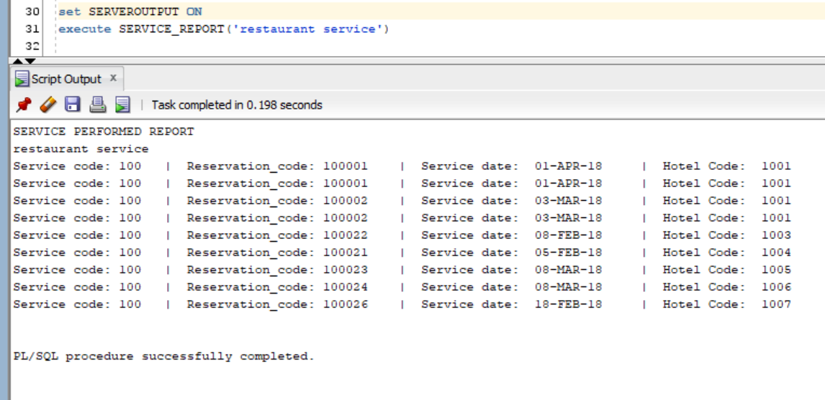

* 1. Total Services Income Report: Given a hotelID, calculate and display income from all services in all reservations in that hotel.

**---------------------Kabin Dulal-------------------------**

--Procedure Created By Kabin Dulal

-- This procedure is used to add a service revenue

--Inputs hotel code

--The output will be a revenue report

**create** **or** **replace** **Procedure** Service_revenue**(**H_code **in** **number)**

**is**

Total_r **number;**

H_stat **varchar(**30**);**

No_hotel **exception;**

**Begin**

**select** Hotel_status **into** H_stat **from** hotels **where** Hotel_code**=**H_code**;**

**if** H_stat **is** **null** **or** h_stat **=** 'sold' **then**

**raise** No_hotel**;**

**end** **if;**

**select** **sum(**RS**.**service_rate**)** **into** Total_r **from** SERVICE_PERFORMED SP**,** reservations R**,** ROOM_SERVICES RS **where**

SP**.**RESERVATION_CODE**=**R**.**RESERVATION_CODE **and**

SP**.**SERVICE_CODE**=**RS**.**SERVICE_CODE

**and** Hotel_code**=** H_code**;**

**if** total_r **is** **null** **then**

dbms_output**.**put_line**(**'This hotel does not have any Service revenue yet'**);**

**else**

dbms_output**.**put_line**(**'Hotel code: '**||**H_code**||** ' | Total revenue from services: $'**||**Total_r**);**

**end** **if;**

**exception**

**when** no_hotel **then**

dbms_output**.**put_line**(**'This hotel is either sold or does not exist.'**);**

**end;**

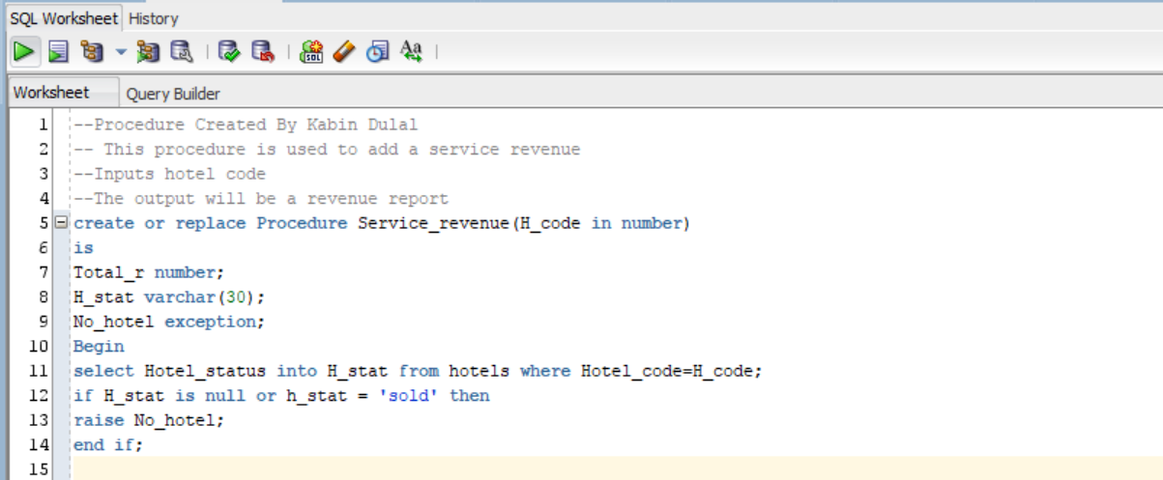

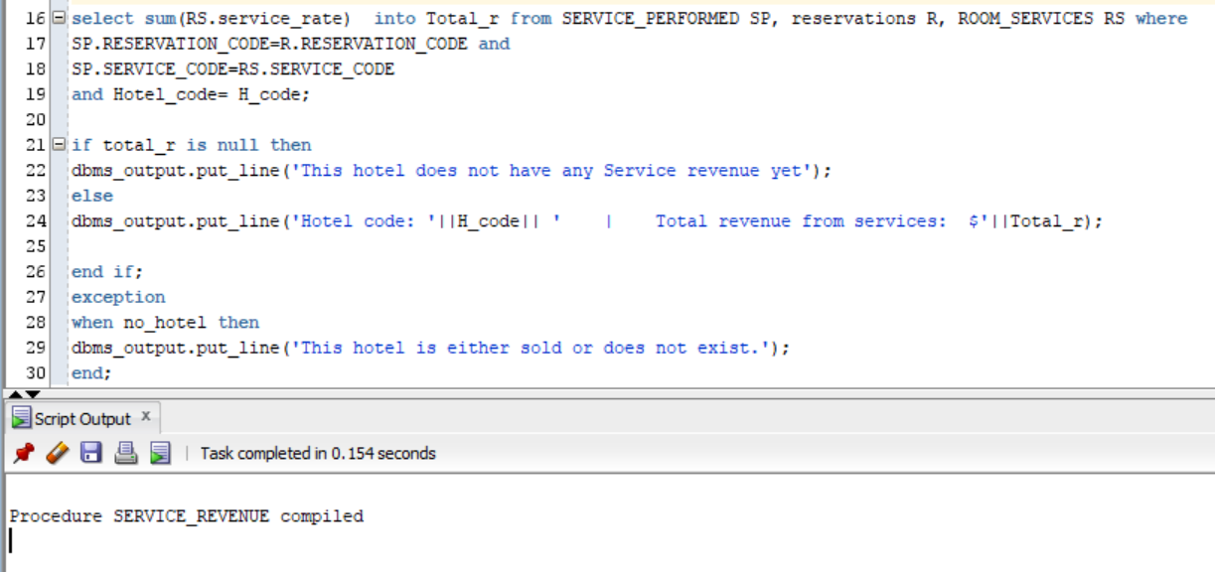

**set** SERVEROUTPUT **ON**

**execute** service_revenue **(**1005**);**

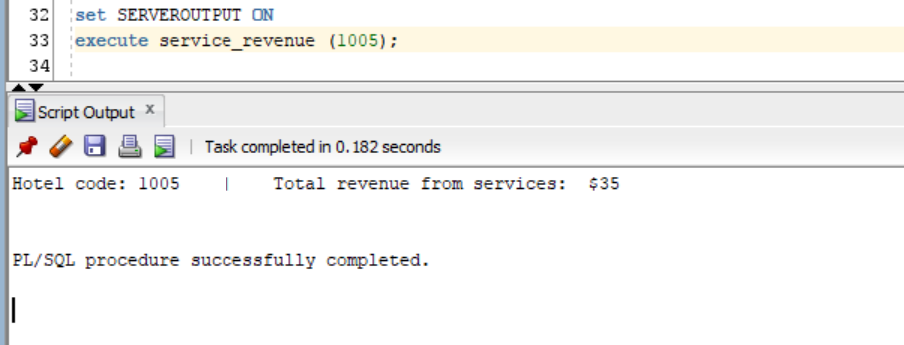

**set** SERVEROUTPUT **ON**

**execute** service_revenue **(**1009**);**

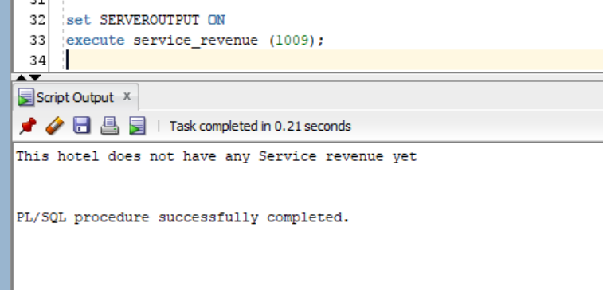

**set** SERVEROUTPUT **ON**

**execute** service_revenue **(**1008**);**

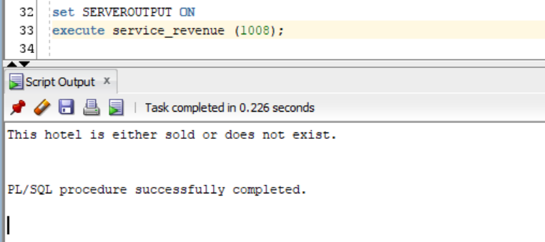

Member 5: Split

* 1. Show reservations: display all rooms reserved in all hotels

**--------------------Diwakar Sharma-------------------------**

--Procedure Created By diwakar Sharma

-- This procedure is used to display all reserved rooms in all hotel

--Inputs none

--The output will be booked rooms list

**create** **or** **replace** **procedure** display_all_rooms -- procedure created

**is**

**cursor** c1

**is**

**select** **\*** **from** reservations **where** -- sql statement for reservation

reservation_stat **=** 'Booked'**;**

r2 c1**%rowtype;**-- it store sql statement with c1 cusor

**begin**

**open** c1**;**

dbms_output**.**put_line**(**'----------------------------------------Hotel reservations Report--------------------------------------------'**);**

dbms_output**.**put_line**(**'-------------------------------------------------------------------------------------------------------------'**);**

**loop**

**fetch** c1 **into** r2**;**

**exit** **when** c1**%**notfound**;**

dbms_output**.**put_line**(**'Hotel_code : '**||** r2**.**hotel_code**||**' | Room Code :'**||**R2**.**room_code**);**

dbms_output**.**put_line**(**'Reservation_code :'**||** r2**.**reservation_code**||**' | Reservation status : '**||**r2**.**reservation_stat**);**

dbms_output**.**put_line**(**'------------------------------------------------------------------------------------'**);**

**end** **loop;**

**close** c1**;**

**exception**-- if not found it will give exception

**when** no_data_found **then**

dbms_output**.**put_line**(**'There is no information available'**);**

**end;**

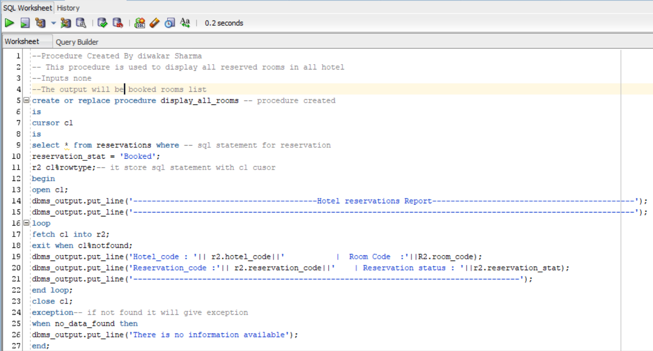

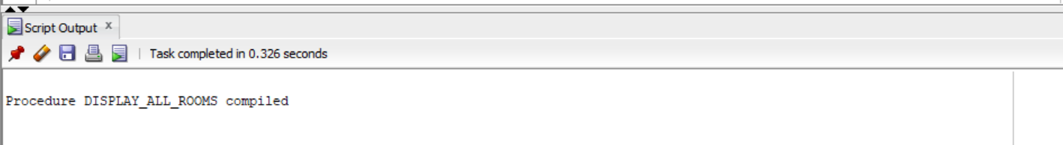

**set** SERVEROUTPUT **ON**

**execute** DISPLAY_ALL_ROOMS**;**

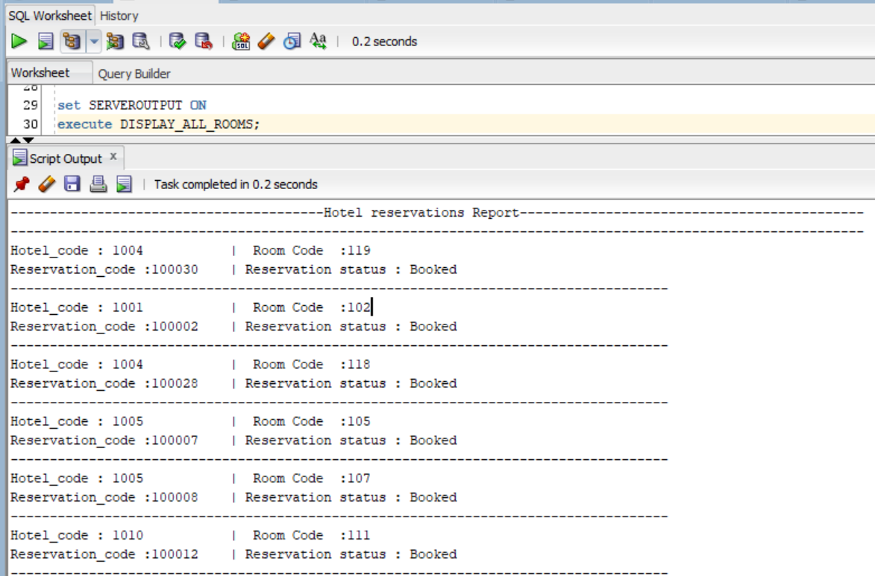

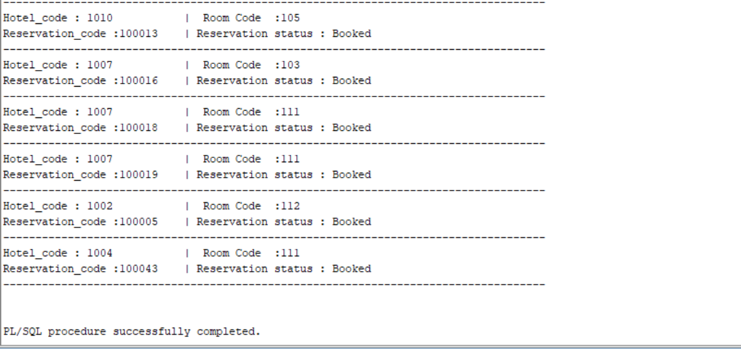

* 1. Show available rooms by type: Given a hotel ID, display the count of all available rooms by room type.

**--------------------Diwakar Sharma-------------------------**

--Procedure Created By diwakar Sharma

-- This procedure is used to display all available rooms in all hotel by room type

--Inputs hotel code

--The output will becount of room type

**create** **or** **replace** **procedure** View_available**(**H_code **in** **Number)** -- creates procedure name View_available

**is**

**cursor** c1 **is**

**select** RT**.**room_desc**,** **count(**RT**.**room_desc**)as** Available

**from** rooms R**,** room_types RT **where**

R**.**Room_status **=** 'open' **and**

R**.**hotel_code **=** H_code **and**

RT**.**room_type_code **=** R**.**Room_type_code **And**

R**.**room_code **not** **in** **(select** room_code **from** RESERVATIONS

**where** reservation_stat **=** 'Booked' **and** **sysdate** **not** **between** Check_in_date **and** CHECK_OUT_DATE**)**

**group** **by** RT**.**room_desc**;**

excep **exception;** -- decare exception

r2 c1**%rowtype;**

hotel_c **number;**

**begin**

**select** hotel_code **into** hotel_c **from** hotels **where** hotel_code**=**h_code**;**

**if** hotel_c **<**1 **then**

**raise** no_data_found**;**

**else**

**open** c1**;**

DBMS_OUTPUT**.**PUT_LINE**(**'-----------------------------Available room Type and count in Hotel '**||** H_code**||**'----------------------------'**);**

DBMS_OUTPUT**.**PUT_LINE**(**'-----------------------------------------------------------------------------------------------------'**);**

**loop**

**FETCH** c1 **INTO** R2**;**

**exit** **when** c1**%**notfound**;**

DBMS_OUTPUT**.**PUT_LINE**(**'Room Type : '**||** R2**.**room_desc**||**' | Units Available : '**||**R2**.**available**);**

**end** **Loop;**

**close** c1**;**

**end** **if;**

**exception**

**when** no_data_found **THEN** -- show what will be exception

DBMS_OUTPUT**.**PUT_LINE**(**'Hotel Invalid'**);**

**end;**

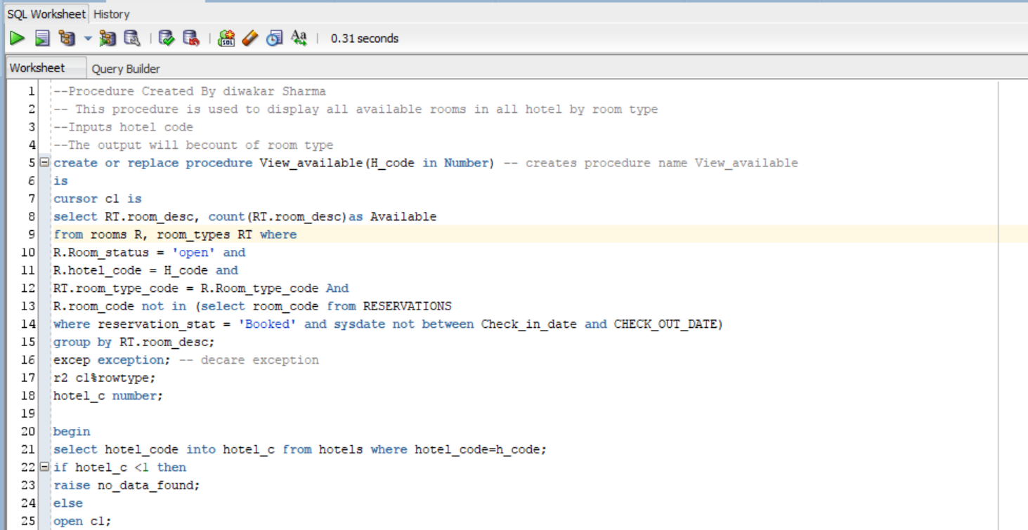

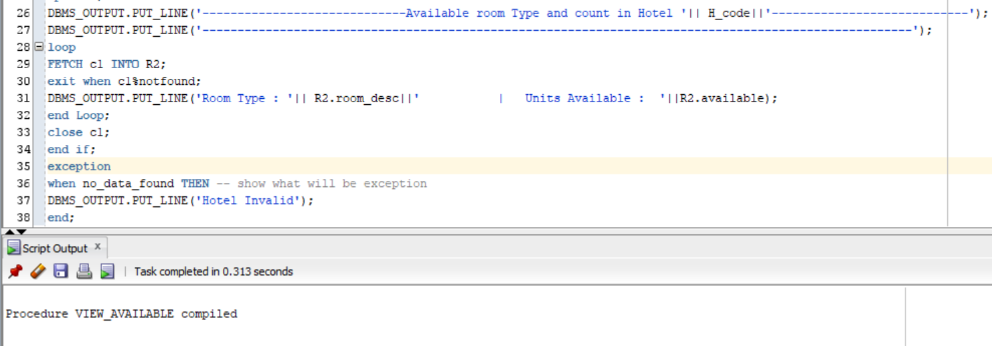

**set** serveroutput **on**

**execute** View_available**(**1001**);**

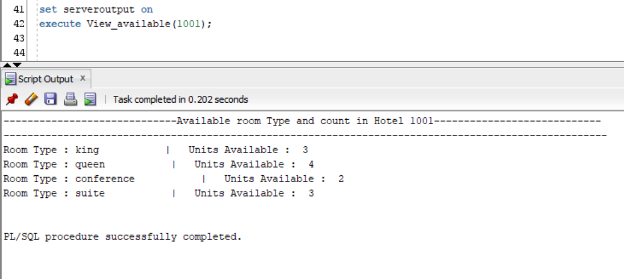

**set** serveroutput **on**

**execute** View_available**(**100031**);**

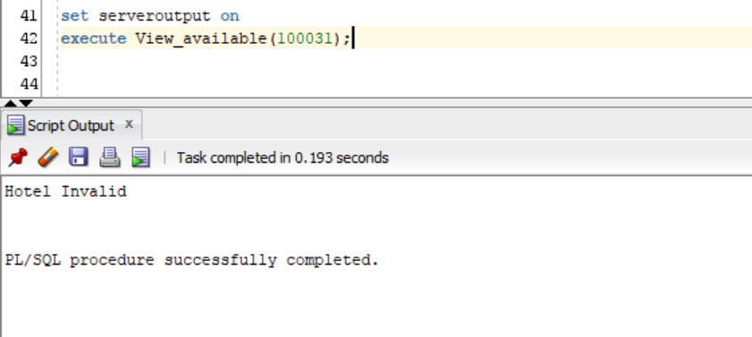

* 1. Room Checkout Report: Input: ReservationID Output:
     + Guest name
     + Room number, rate per day and possibly multiple rooms (if someone reserved several rooms)
     + Services rendered per date, type, and amount
     + Discounts applied (if any)
     + Total amount to be paid

**---------------------Kabin Dulal-------------------------**

**This procedure is used to generate Bill/ It does not make a payment**

--Procedure Created By Kabin Dulal

-- This procedure is used to check out report

--Inputs reservation code

--The output will be a check out report

**create** **or** **replace** **procedure** Generate_Bill **(**r_code **in** **number)**

**is**

rate **number;**

Cust_fname **varchar2(**30**);**

Cust_lname **varchar2(**30**);**

G_name **varchar2(**60**);**

num_days **number;**

service_total **number;**

room_total **number;**

discount **number;**

Dis **number;**

Bill_Total **number;**

Net_total **number;**

room_num **number;**

Num_bed **number;**

Room_D **varchar(**50**);**

H_code **number;**

no_data **EXCEPTION;**

**begin**

rate**:=**Get_rate**(**r_code**);**

**if** rate**<**0 **then**

**raise** no_data**;**

**end** **if;**

**select** check_out_date **-** check_in_date **into** Num_days **from** RESERVATIONS **where** reservation_code**=**r_code**;**

**select** hotel_code **into** H_code **from** Reservations **where** reservation_code**=**R_code**;**

**select** **sum(**RS**.**Service_rate**)into** service_total **from** ROOM_SERVICES RS**,** service_performed SP **where**

RS**.**service_code**=**SP**.**SERVICE_CODE **and**

SP**.**RESERVATION_CODE **=** r_code**;**

**select** guest_name **into** G_name **from** Reservations **where** reservation_code**=** r_code**;**

room_total**:=** num_days **\***rate**;**

Bill_Total**:=(**room_total **+** service_total**);**

discount**:=** get_discount**(**r_code**);**

**if** discount **>**0 **then**

dis**:=** **((**bill_total**\*** discount**)/**100**);**

Net_total**:=** **(**Bill_total**-**dis**);**

**else**

dis**:=**0**;**

net_total**:=** Bill_total**;**

**End** **if;**

**select** H**.**customer_Fname**,** H**.**customer_lname **into** cust_fname**,** cust_lname **from** H_CUSTOMERS H**,** RESERVATIONS R **where**

H**.**customer_code **=** R**.**customer_code **and**

R**.**reservation_code **=** r_code**;**

**select** RT**.**room_desc**,**RT**.**No_of_beds**,** RM**.**room_code **into** Room_d**,**Num_bed**,** Room_num

**from** reservations R**,** Rooms RM**,** Room_types RT **where**

R**.**reservation_code**=**r_code **and**

RM**.**hotel_code**=**H_Code **and**

R**.**room_code**=**RM**.**room_code **and**

RM**.**room_type_code **=**RT**.**Room_type_code**;**

dbms_output**.**put_line**(**'Billing date: ' **||** **to_char(SYSDATE,**'YYYY-MM-DD HH24:MI:SS'**));**

dbms_output**.**put_line**(**'Reservation_code : ' **||** R_code**||**' | Hotel Code : '**||** h_code**);**

dbms_output**.**put_line**(**'Customer Name : ' **||** Cust_fname **||**' '**||** Cust_lname**);**

dbms_output**.**put_line**(**'Guest Name : ' **||** G_name**);**

dbms_output**.**put_line**(**'-----------------------------------------------------'**);**

dbms_output**.**put_line**(**'Room Number: ' **||** Room_num**||** ' | Room Type: '**||** Room_D**||**' | Number of Beds : '**||** Num_bed**);**

dbms_output**.**put_line**(**'Room Total for ' **||** Num_days **||**' days * $' **||**rate**||**'/day : $'**||** room_total**);**

dbms_output**.**put_line**(**'Service Total : $' **||** service_total**);**

dbms_output**.**put_line**(**'-----------------------------------------------------'**);**

dbms_output**.**put_line**(**'Bill Total: ----------------> $' **||** Bill_Total**);**

dbms_output**.**put_line**(**'Discount percent : ' **||** discount **||**'% -$'**||** dis**);**

dbms_output**.**put_line**(**'====================================================='**);**

dbms_output**.**put_line**(**'Total Amount to be paid: $'**||** net_total**);**

**Exception**

**when** no_data **then**

dbms_output**.**put_line**(**'This reservation does not Exist'**);**

**end;**

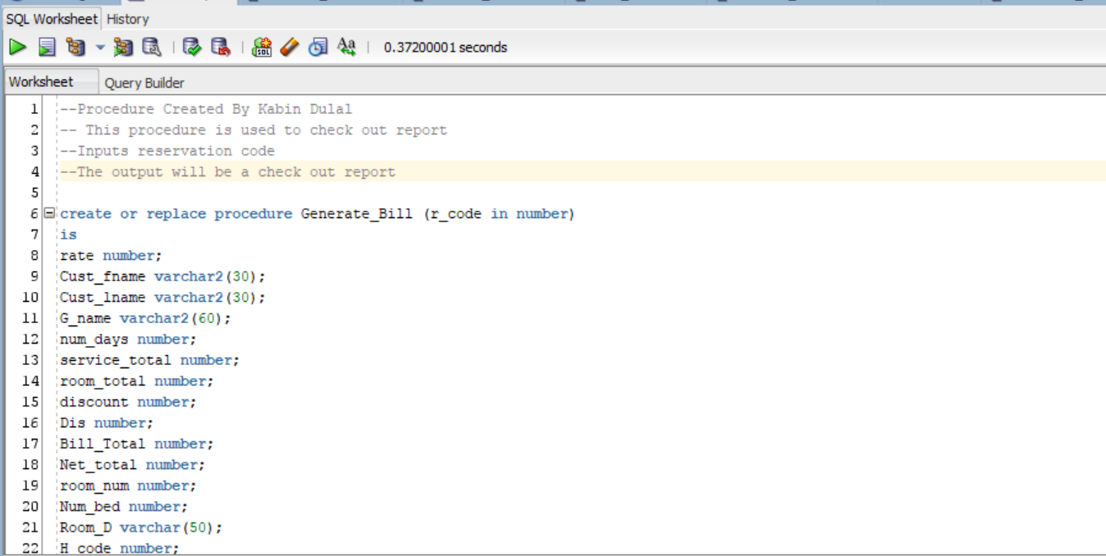

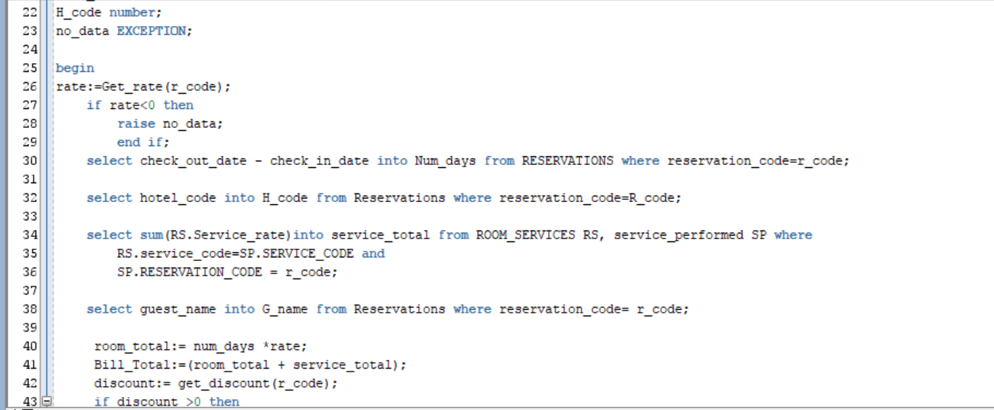

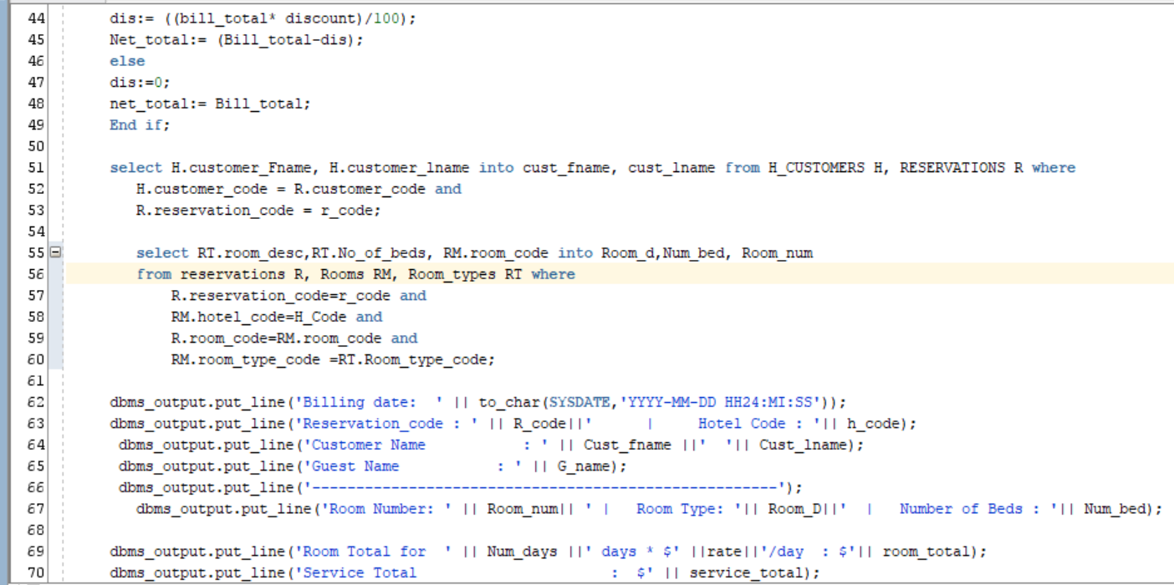

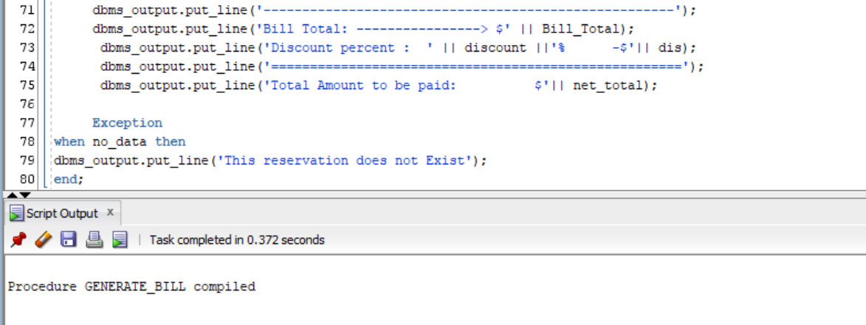

**set** SERVEROUTPUT **ON**

**execute** generate**(**100002**);**

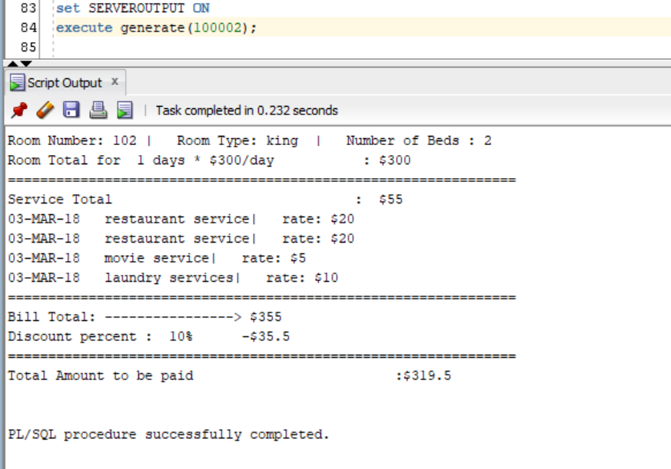

**set** SERVEROUTPUT **ON**

**execute** generate**(**12302**);**

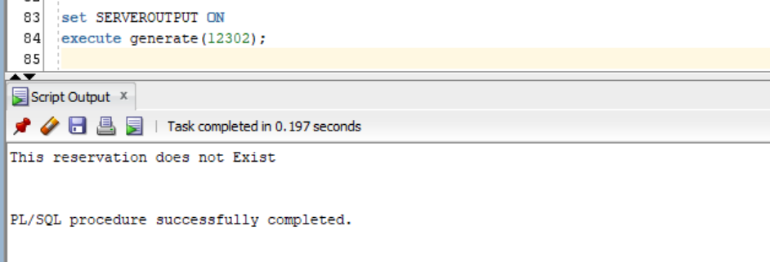

**The Following procedure is used to make a payment/ This inserts the data to Bill**

--Procedure Created By Kabin Dulal

-- This procedure is used make a payment

--Inputs reservation code, and payment type

--The output will be a check out report

**create** **or** **replace** **procedure** Make_payment **(**r_code **in** **number,** P_type **in** **varchar2)**

**is**

rate **number;**

num_days **number;**

service_total **number;**

room_total **number;**

discount **number;**

Dis **number;**

Bill_Total **number;**

Net_total **number;**

stat **VARCHAR2(**20**);**

no_data **EXCEPTION;**

paid **exception;**

Cancelled **exception;**

**begin**

rate**:=**Get_rate**(**r_code**);**

**if** rate**<**0 **then**

**raise** no_data**;**

**end** **if;**

**select** check_out_date **-** check_in_date **into** Num_days **from** RESERVATIONS **where** reservation_code**=**r_code**;**

**if** num_days **is** **null** **then**

**raise** no_data**;**

**end** **if;**

**select** **sum(**RS**.**Service_rate**)into** service_total **from** ROOM_SERVICES RS**,** service_performed SP **where**

RS**.**service_code**=**SP**.**SERVICE_CODE **and**

SP**.**RESERVATION_CODE **=** r_code**;**

**if** service_total **is** **null** **then**

service_total**:=**0**;**

**end** **if;**

**select** Reservation_stat **into** stat **from** reservations **where** reservation_code**=**R_code**;**

**If** stat**=**'checked out' **then**

**raise** paid**;**

**elsif** stat**=**'Cancelled' **then**

**raise** Cancelled**;**

**end** **if;**

room_total**:=** num_days **\***rate**;**

Bill_Total**:=(**room_total **+** service_total**);**

discount**:=** get_discount**(**r_code**);**

**if** discount **>**0 **then**

dis**:=** **((**bill_total**\*** discount**)/**100**);**

Net_total**:=** **(**Bill_total**-** dis**);**

**else**

dis**:=**0**;**

net_total**:=** Bill_total**;**

**End** **if;**

**Insert** **into** Bills **values** **(** Billing_code_seq**.nextval,** r_code**,**room_total**,**service_total**,**Bill_total**,** dis**,**Net_total**,**P_type**,** **sysdate);**

**update** reservations **set** reservation_stat **=** 'checked out' **where** reservation_code**=**R_code**;**

dbms_output**.**put_line**(**'Payment for Reservation ' **||**r_code**||**' is completed on '**||** **to_char(SYSDATE,**'YYYY-MM-DD HH24:MI:SS'**));**

dbms_output**.**put_line**(**'Thank You for the payment'**);**

**Exception**

**when** no_data **then**

dbms_output**.**put_line**(**'This reservation does not Exist'**);**

**when** paid **then**

dbms_output**.**put_line**(**'Reservation is Already paid'**);**

**when** Cancelled **then**

dbms_output**.**put_line**(**'Reservation is cancelled, No payment necessary'**);**

**end;**

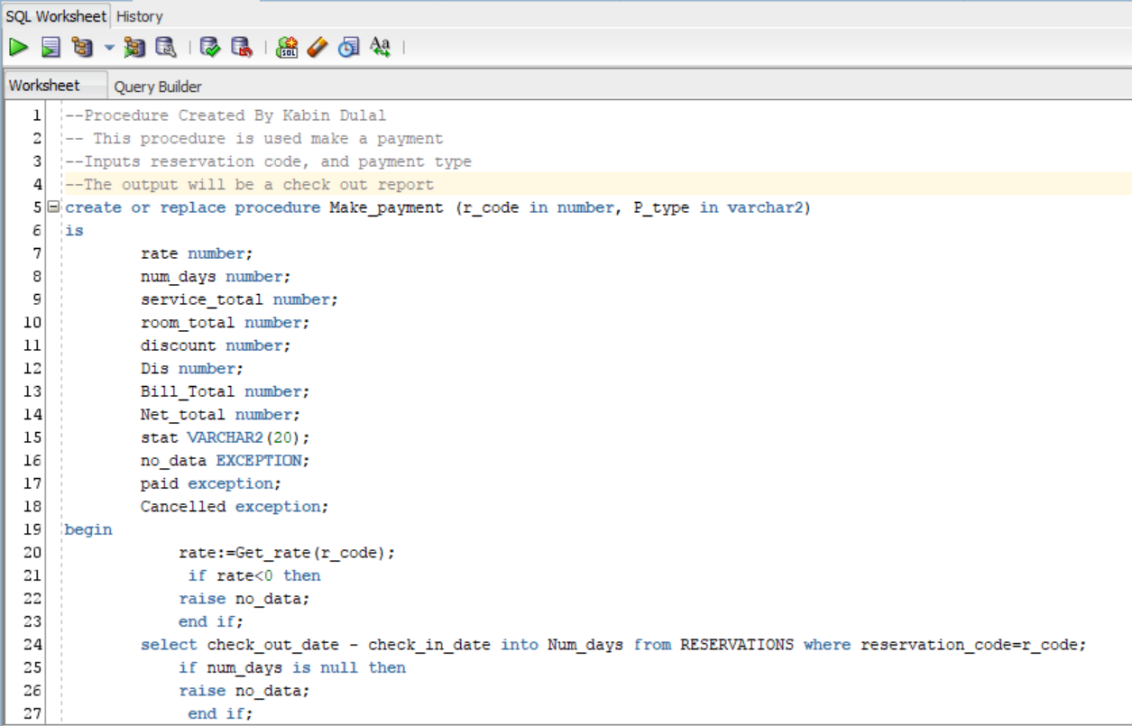

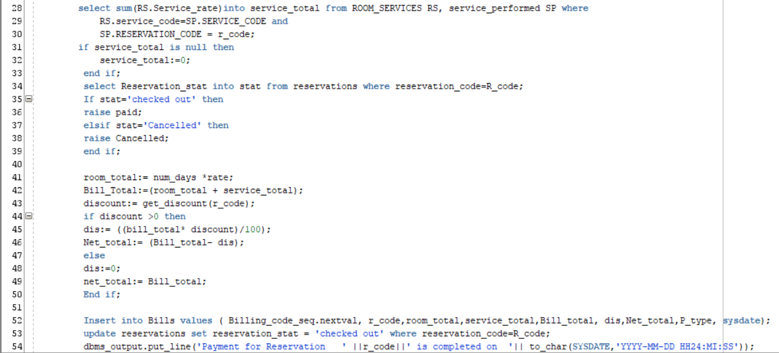

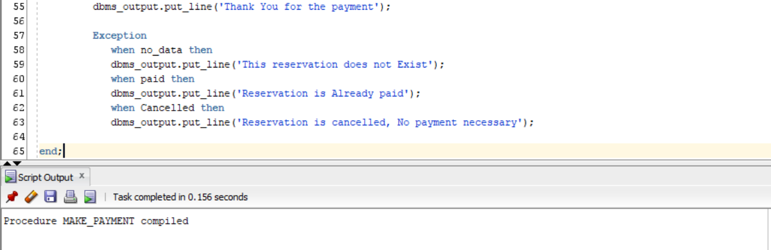

**Set** SERVEROUTPUT **ON**

**execute** MAKE_PAYMENT**(**100029**,**'cash'**);**

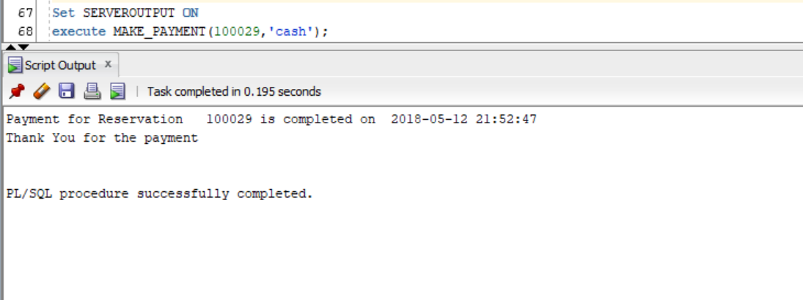

**Set** SERVEROUTPUT **ON**

**execute** MAKE_PAYMENT**(**10012**,**'cash'**);**

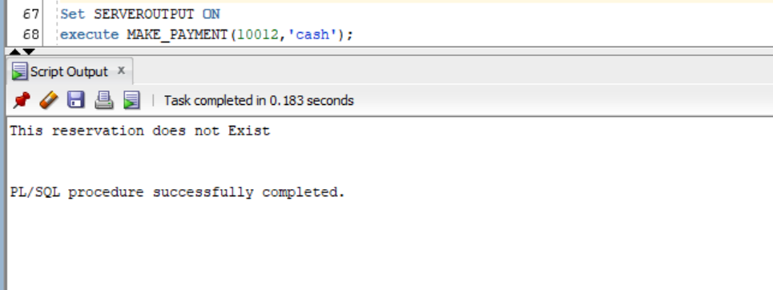

* 1. Income By State Report: Input is state. Print total income from all sources of all hotels by room type and service type in the given state. Include discounts.

**---------------------Sijan karki-------------------------**

--Procedure Created By Sijan Karki

-- This procedure is used to view income report by state

--Inputs state

--The output will be report

**create** **or** **replace** **procedure** income_report**(state** **in** **varchar2)** --creating a procedure

**is**

**cursor** c2 **is** --creating a cursor c2

**select** **sum(**rs**.**service_rate**)** **as** s_inc**,** rs**.**service_desc

**from** room_services rs**,** service_performed sp**,** reservations r**,** hotels h --SQL statements

**where** rs**.**service_code**=**sp**.**service_code **and**

sp**.**reservation_code **=** r**.**reservation_code **and**

r**.**hotel_code **=** h**.**hotel_code **and**

h**.**hotel_state **=** **state**

**group** **by** rs**.**service_desc**;**

**cursor** c1 **is** --creating a cursor c1

**select** **sum(**b**.**room_charge**)** **as** r_inc**,** rt**.**room_desc**,** h**.**hotel_state**,** **sum(**b**.**discount**)** **as** tot_d

**from** reservations r**,** Rooms rm**,** room_types rt**,** bills b**,** hotels h

**where** rt**.**room_type_code **=** rm**.**room_type_code **and** --SQL statements

rm**.**hotel_code **=** r**.**hotel_code **and**

rm**.**room_code **=** r**.**room_code **and**

r**.**hotel_code **=** h**.**hotel_code **and**

h**.**hotel_state **=** **state** **and**

r**.**reservation_code **=** b**.**reservation_code

**group** **by** rt**.**room_desc**,** h**.**hotel_state**;**

x1 c1**%rowtype;**

x2 c2**%rowtype;**

i_state **varchar2(**20**);**

No_hotel **exception;**

**Begin**

**select** **distinct** hotel_state **into** i_state **from** hotels **where** hotel_state **=** **state;**

**if** i_state **is** **null** **then** --conditional statement

**raise** no_data_found**;**

**else**

dbms_output**.**put_line**(**'*****************************************************************************'**);**

dbms_output**.**put_line**(**'--------------------------Income report for "'**||state||**'"----------------------------'**);**

dbms_output**.**put_line**(**'*****************************************************************************'**);**

dbms_output**.**put_line**(**'INCOME FROM ROOM RESERVATIONS'**);**

**open** c1**;**

**loop**

**fetch** c1 **into** x1**;** --c1 is fetched into x1

**exit** **when** c1**%**notfound**;**

dbms_output**.**put_line**(**x1**.**room_desc**||**' : $'**||**x1**.**r_inc**||** ' | Discount : $'**||** x1**.**tot_d**);**

**end** **Loop;**

**close** c1**;**

dbms_output**.**put_line**(**'*****************************************************************************'**);**

dbms_output**.**put_line**(**'INCOME FROM ROOM SERVICES'**);**

**open** c2**;**

**loop**

**fetch** c2 **into** x2**;** --c1 is fetched into x2

**exit** **when** c2**%**notfound**;**

dbms_output**.**put_line**(**x2**.**service_desc**||**' : $'**||**x2**.**S_inc**);**

**end** **Loop;**

**end** **if;**

**exception** --exception handeling

**when** no_data_found **then**

dbms_output**.**put_line**(**'No hotels in this state or the state is Invalid'**);**

**end;**

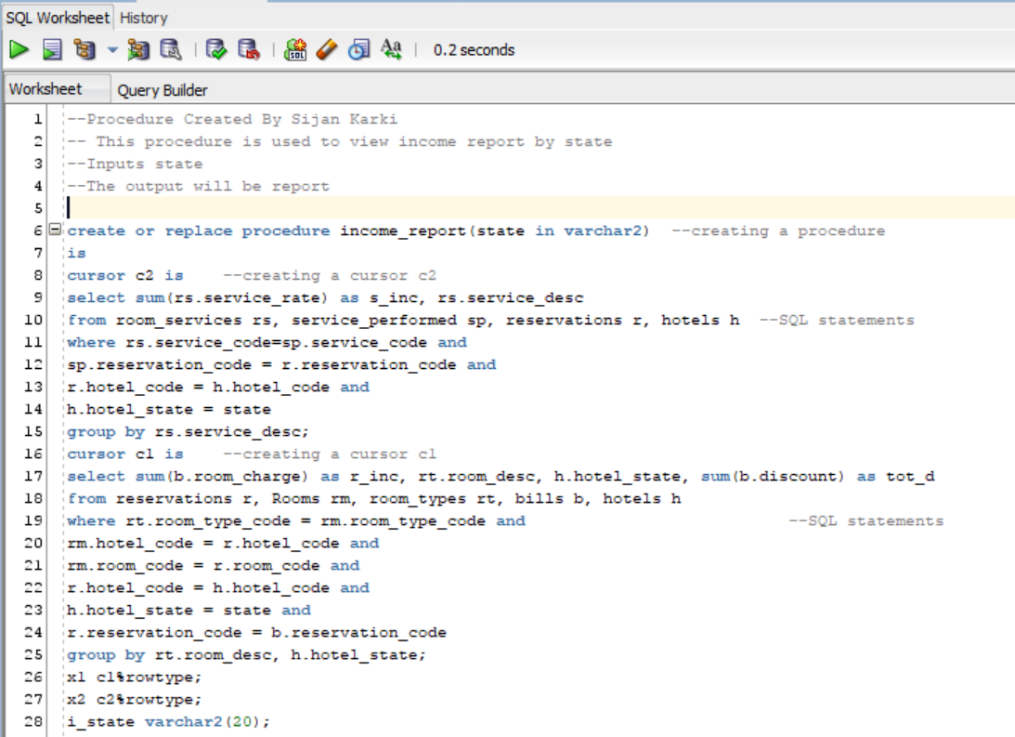

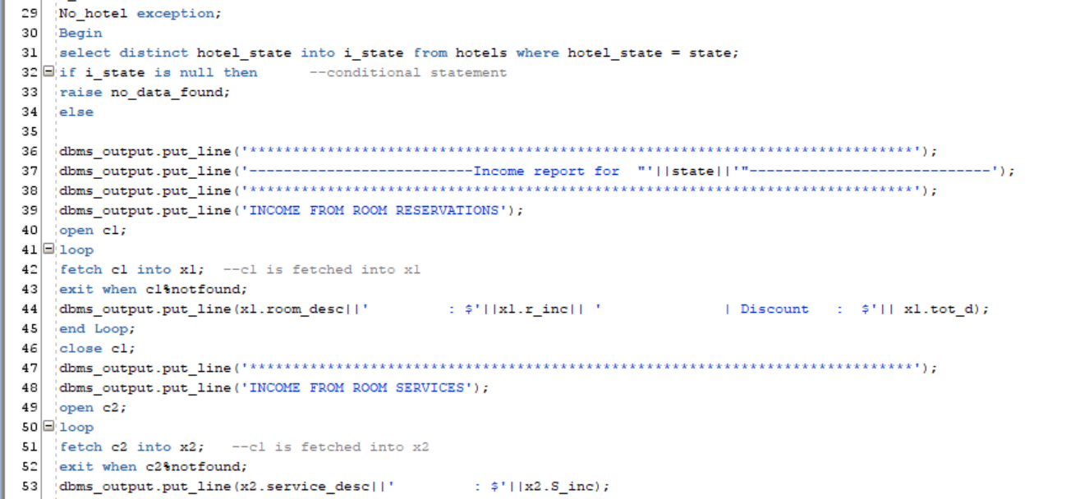

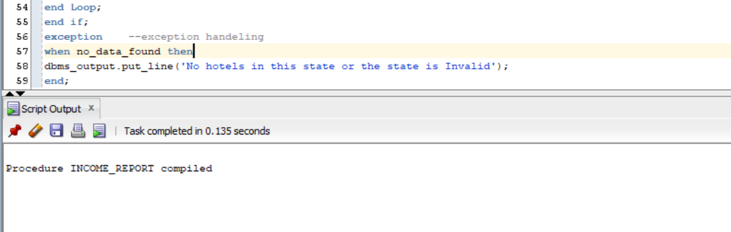

**set** SERVEROUTPUT **ON**

**execute** INCOME_REPORT**(**'MD'**);**

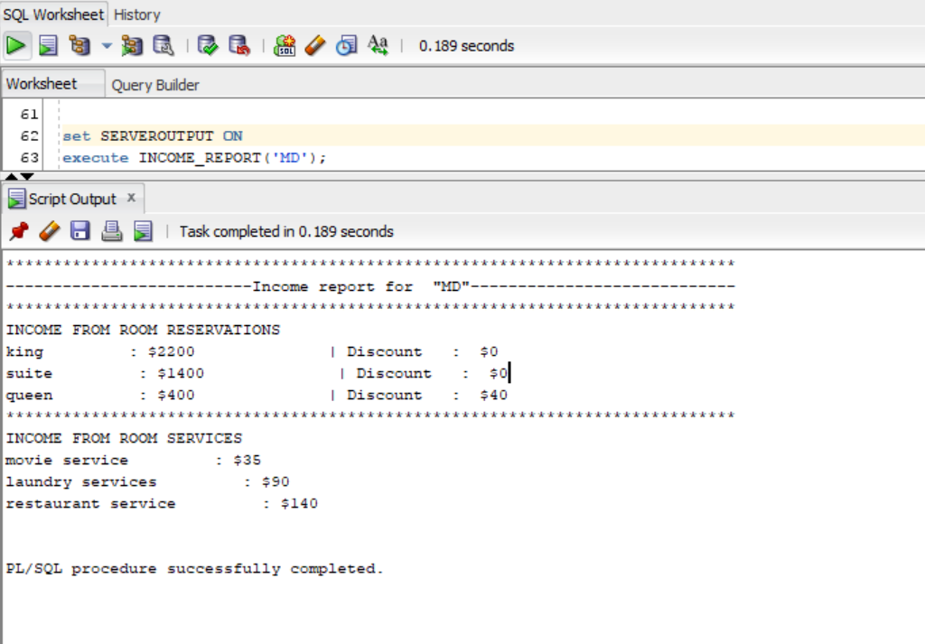

**set** SERVEROUTPUT **ON**

**execute** INCOME_REPORT**(**'FL'**);**

